ARAMARK –COLISEUM GUIDELINES

- Pants must be all Black: slacks/dickies/Dockers/or khaki material are mandatory.
- No jeans, sweats, tights, leggings, capris, tight fitting material or spandex. You may be sent home if not in the correct uniform.
- Shirts must be all black, button down with a collar.
- Shoes must be all black (to include the laces and the soles), preferably slip resistant. You may not work in Uggs, dress boots, ballerina flats, heels, flip flops or any type of open toe shoe.
- Please cover or remove all facial piercings: nose rings, studs, jewels, etc.
- All tattoos must be covered. Arm and neck tattoos must be covered with an all-black shirt.
- Only natural hair color is permitted. You may not wear extreme colors such as: pink, purple, green, burgundy, bright red, etc. Hair longer than shoulder length must be pulled back at all times.
- Hair nets are required for all concession stand positions and hats are required to work in the kitchen. Logo or team apparel hats are not permitted. Hats must be solid black.
- Nails: Nails may not be longer than ¼ inch long and the only permissible colors are nude, clear or French Manicure.
- Bags & BACKPACKS must be clear and no larger than 12X6X12. We will no longer allow bags into the building that are not CLEAR! If you are working in the Culinary main kitchen, you must supply your own lock! You will no longer be allowed to store your bag in the Chef’s office.
We are not responsible for lost or stolen items
- Parking will be in the C Lot the majority of the time (Please see below)
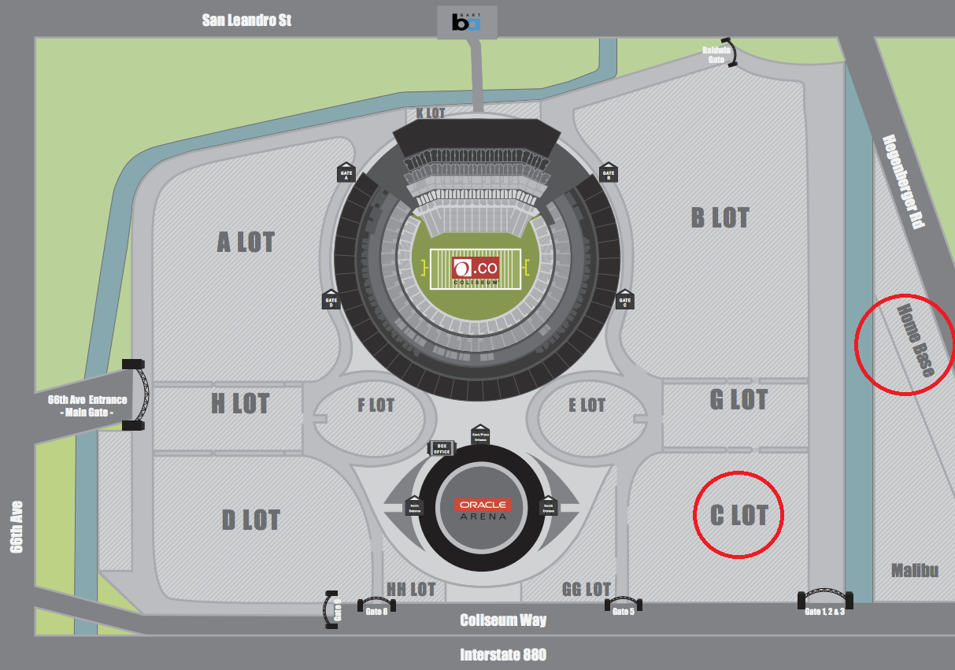
**You will be notified if parking is off property (Home Base or Malibu Lot)**
- Check in is located through the Employee Entrance at Gate C- Championship Plaza.

