MASTER OF SERVICES AGREEMENT FOR TEMPORARY LABOR SERVICES (“Agreement”) effective as of January 1st, 2025 (“Effective Date”), is entered into by and between, Cirque du Soleil America Newco Inc, a company legally constituted, having a place of business at 1151 Grier Drive, Suite C, Las Vegas, NV 89 119 USA (“Company” or “Cirque”) and The Service Companies, Inc. a company legally constituted, having a place of business at 2900 Monarch Lakes Boulevard, Suite 202, Miramar, FL 33027 (Supplier). Company and Supplier are also individually referred to as Party or collectively as Parties.
WHEREAS Company wishes to retain the services of Supplier, on a Market basis, to provide temporary labor services for its touring and/or resident shows (“Shows”) and Supplier hereby agrees to provide such services to Company, in accordance with the terms and conditions set forth in this Agreement.
NOW THEREFORE, THE PARTIES AGREE AS FOLLOWS:

SERVICES

Supplier agrees to provide to Company temporary labor staff services (“Assigned Employees”) in different markets (each a “Market” and collectively “Markets”) where its Shows will be presented during the Term, in accordance with:

The applicable hourly bill rates (“Bill Rates”) for the Markets as set forth in Exhibit A;

Company Invoicing details as set forth in Exhibit B;

Company’s tour plan as set forth in Exhibit C;

The general conditions set forth in Exhibit D and Exhibit E, including Company’s staffing requirements for the Market (“Staffing Requirements”) and Company’s role and responsibilities

The Services shall be performed in a professional manner and in accordance with: (i) industry standards; (ii) Company policies and guidelines as they may be communicated from time to time by Company to Supplier; and (iii) all applicable laws and regulations.

All Assigned Employees are and shall remain throughout the Term of this Agreement, employees of Supplier and shall not be considered or treated as employees of Company. The remuneration and provision of any benefits to the Assigned Employees, including, if applicable, but not limited to pension fund contributions, payroll taxes, social security and Medicare charges and other statutory costs payable to or in respect of such Assigned Employees, shall be for the sole account of Supplier. Nothing contained in the Agreement shall entitle the Assigned Employees to any benefits or compensation from Company. Supplier shall report and pay the employer's share of applicable social security and Medicare, workers' compensation and any other employment taxes, including but not limited to unemployment insurance, pension fund contributions, with respect to all remuneration and benefits received by the Assigned Employees and make and declare the required tax and social security withholdings. Supplier shall also comply with all provisions of the Patient and Affordable Care Act of 2010, as amended (“ACA”), as applicable to the Assigned Employees, including the employer shared responsibility provisions relating to the offer of “minimum essential coverage” to “full time” employees (as those terms are defined in the Internal Revenue Code §4980H and related regulations) and the applicable employer information reporting provisions under Internal Revenue Code §6055 and §6056 and related regulations.

Supplier shall ensure close monitoring of the quality of the Services provided hereunder by maintaining constant communication with Company’s Representatives. Supplier undertakes to conduct close follow-ups in order to assess the quality of the Services performed and to take, if necessary, appropriate measures to remedy any decrease and/or any dissatisfaction with respect to the quality of the Services offered which has been identified as part of these follow-ups.

TERM

This Agreement shall be effective from the Effective Date until April 30st, 2026, unless terminated before such date pursuant to Section 9 (“Term”).

PAYMENT, invoices and taxes

In consideration of the Services performed by Supplier and subject to its respect of all of its obligations under this Agreement, Company undertakes to pay to Supplier the Bill Rates indicated in Exhibit A and the taxes set forth in Sections 3.7 and 3.8.

It is understood and agreed by Supplier that the Bill Rates are inclusive namely of:

All statutory burdens and administrative charges, allowances and all other statutory charges (e.g., payroll tax, workers’ compensation, social security and Medicare contributions, insurance premiums, etc.).

Supplier’s administration and profit mark-up, which shall be fixed for the Term of this Agreement.

Supplier’s system to maintain at any time during the Term, the number of Assigned Employees in accordance with the Staffing Requirements submitted by Company (e.g.: standby or back-up employees to substitute any Assigned Employee not showing up for any reason);

Supplier’s time capturing system and corresponding equipment cost; and

Candidates search, recruiting, hiring, assigning and managing the placement of Assigned Employees, including: (i) criminal background checks, to the extent allowed under applicable law for all positions involving cash handling (if applicable), and driver’s record check to the extent allowed under applicable law for all positions involving motor vehicle operation (if applicable); and (ii) Supplier’s workforce approach to target, screen, recruit and retain candidates with sales talent and skills for some designated positions to be fulfilled (e.g. sales behavioral testing, sales benchmarking, sales best practices training) (if applicable).

Any increases in the pay rates as indicated in Exhibit A, shall have no impact on the Bill Rates.

On a weekly basis, Supplier shall submit the Assigned Employees’ time records to Company for approval.

Based on the approved time records, Supplier shall submit weekly electronic invoices to Company. Should Company require any change on an invoice, Supplier shall perform said modification and issue a revised invoice.

Invoices shall be sent electronically to the Company Representative and to Company International Headquarters’ Finances Department (cds.payables@cirquedusoleil.com). Company agrees to pay the invoices within 45 days after their receipt. Any amounts unpaid after forty-five (45) days will bear interest at the lesser of 1½% per month or the maximum legal rate. This provision applies exclusively from the date of receipt of the invoice; the invoice must be accurate, complete, and free of errors.

Supplier shall have thirty (30) days after the end of a Market to send its final invoice to Company together with a Market release letter (“Market Release Letter”), indicating that all charges have been invoiced to Company for such Market. Supplier understands and agrees that Company will not pay for any additional charges invoiced after the receipt of this final invoice and Market Release Letter. Company may refuse to pay any incoming invoice after the agreed-upon delay without being in breach of this Agreement. The Market Released Letter shall include: (i) the Show name; (ii) the Market name; (iii) the total amount billed to Company for such Market; and (iv) the last invoice details (invoice date, number, and amount).

Where applicable, Company shall be responsible for any applicable sale, use, good and service, value-added, excise tax or any other applicable tax, with respect to the Services it will receive under this Agreement (“Taxes”). If applicable, Supplier shall invoice the amount of any such Taxes which it has the obligation by law to collect from Company and shall remit such amount to the appropriate governmental authorities.

Should any compensation payable by Company to Supplier be subject to withholding taxes, Company shall retain the appropriate amount and shall remit such amount to the applicable governmental authorities.

VOLUME REBATE

Company is entitled to receive payments relating to the annual volume rebate described below (Volume Rebate).

This is a step-based, not cumulative, rebate program. The qualifying rebate percentage will be calculated based on the volume of annual spend above the thresholds.
Annual Spend Threshold | Aggregate Rebate
USD $0- $999,999 | 0% rebate
USD $1,000,000- $1,999,999 | 1% rebate
USD $2,000,000-$2,999,999 | 2% rebate
USD $3,000,000-$3,999,999 | 2.5% rebate
USD $4,000,00-$4,999,999 | 2.75% rebate
USD $5,000,000+ | 3% rebate

The Volume Rebate will be based on annual spend, which refers to all invoiced Bill Rates paid by Company under this Agreement or under any other agreement between Company (including any of its affiliated entities) and Supplier (including any of its affiliated entities) to the extent any such agreement includes corresponding obligations to pay such a volume rebate, excluding any Bill Rates paid by Company for Assigned Employees provided by subcontractors.

The Volume Rebate will be paid to Company annually no later than sixty (60) days following each anniversary date of the Agreement during the Term.

ModificationS

Company may, at any time during the Term, make changes to its tour plan, including but not limited to the dates of confirmed Markets, the number and duration of Shows in any given confirmed Market and/or the job profiles and Staffing Requirements for each confirmed Market or add a new Market. Company shall notify Supplier in writing of any such changes. Supplier understands and agrees that it shall not be compensated in any way if Cirque makes such changes to the Tour Plan.

Each Party hereby acknowledges that Confidential Information of the other Party is a valuable trade secret of such Party and each Party hereby agrees to maintain and protect same in the strictest confidence, not to disclose same to any third party without the other Party's prior written consent and not to use same other than for the purposes of performing its obligations hereunder. Each party shall be liable for any failure by its affiliates, employees, officers, directors, agents, any other person acting on its behalf or subcontractors (including the employees of such persons) to comply with the confidentiality obligations set forth in this Section 6.

CONFIDENTIALITY

In this Section 6, “Confidential Information” shall mean the content of this Agreement and all non-public, confidential or proprietary information disclosed, in any manner whatsoever, by a Party to the other Party, whether before or after the execution of this Agreement. Notwithstanding the foregoing, Confidential Information shall not include: (i) information that was in the public domain prior to its disclosure; (ii) information that enters the public domain without any violation of any obligation of confidentiality; or (iii) information for which the disclosure is required by law.

Each Party hereby acknowledges that Confidential Information of the other Party is a valuable trade secret of such Party and each Party hereby agrees to maintain and protect same in the strictest confidence, not to disclose same to any third party without the other Party's prior written consent and not to use same other than for the purposes of performing its obligations hereunder. Each party shall be liable for any failure by its affiliates, employees, officers, directors, agents, any other person acting on its behalf or subcontractors (including the employees of such persons) to comply with the confidentiality obligations set forth in this Section 6.

INSURANCE

Supplier shall procure and maintain, for the entire duration of the Agreement, with insurance companies authorized to do business in the Territory and with a current A.M. Best Company rating of at least A- or better, the following insurance policies (whether using this or different terminology):
- Commercial general liability insurance covering, on an occurrence basis, all of the Supplier’s services including but not limited to bodily injury including death, personal injury and property damage to third parties, with a limit of at least Five Million United States Dollars (US$5,000,000) per occurrence, including contractual liability, cross liability, liquor liability and food poisoning liability and products and completed operations liability. This limit may be made up of one or more policies totaling the required limits; however, any umbrella or excess liability policies must follow the form of the primary Commercial General Liability policy.
- A Work-related accident insurance covering medical benefits and disability income arising from any work-related injury or illness to Supplier’s Personnel or any other person hired by Supplier, as provided by a private insurer (Workers Compensation or local equivalent) or within the Social Security system in the jurisdiction where the work is being performed, within the statutory limits and an employer’s liability insurance policy each with a limit of at least One Million United States Dollars (US$1,000,000), per accident. This policy shall include an alternate employer endorsement adding Company as the alternate employer and shall include a waiver of subrogation, including direct and indirect subrogation through lien or otherwise, in favor of Company, its subsidiaries, affiliates, employees, officers, directors and agents.
- Automobile Liability insurance covering bodily injury and property damage to third parties, arising out of the use, operation, and maintenance of any owned, non-owned, and hired vehicles, in amount not less than One Million United States Dollars (US$1,000,000), or the equivalent in local currency. Such policy shall include underinsured/uninsured motorist coverage

Under the insurance policy required in Section 7.1 above, Company, its parent, subsidiaries and affiliates and their officers, directors, agents and employees are to be included as additional insured to the insurance policies of the Supplier. Each policy shall provide that its coverage is primary and shall not require the contribution of any other insurance that may be available to Company. All of the above insurance policies shall include a waiver of subrogation, including indirect subrogation through a lien or otherwise, in favor of Company, its parents, subsidiaries and affiliates and their officers, directors, agents and employees.

Supplier shall ensure that the agreements executed with its suppliers and subcontractors include the obligation for such suppliers and subcontractors at their sole cost and expense, to procure and maintain, during the term of their agreement, insurance policies as may be carried by prudent suppliers and subcontractors to cover their assets and activities, including but not limited to general liability insurance, workers compensation and employers’ liability insurance.

Upon execution of the Agreement, Supplier shall provide to Company a certificate of insurance evidencing of the abovementioned insurance policies. Such certificate shall state that the insurance coverage stipulated therein will not be cancelled or modify in any way which reduces the amount of available coverage without at least a thirty (30) calendar day prior written notification to Company and the above general liability insurance policy shall include an endorsement that it is primary and non-contributory with or in excess to any other insurance that may be maintained by Company.

INDEMNIFICATION

Supplier hereby agrees to indemnify and hold harmless Company and its affiliates, and their respective officers, directors, shareholders, employees, agents and representatives (collectively, the “Indemnified Parties”) from and against any loss, damage, cost, expense, liability, claim, obligation, settlement payment, proceeding or other expense of any kind whatsoever, including revenue loss, incurred or suffered by the Indemnified Parties (including reasonable legal fees and expenses and court costs) (“Claims”) arising out of or in connection with the following:

any breach or non-performance of any of Supplier’s representations, warranties or covenants and/or obligations contained in the Agreement; and/or

any property damage and/or any personal injury or death sustained by any person, including employees or agents of the Indemnified Party and any third parties, resulting from any negligent or wrongful act or omission of Supplier, its employees, Assigned Employees, subcontractors or agents in the performance of obligations under this Agreement; and/or

any labour responsibility of Supplier towards the Assigned Employees, for which the Indemnified Parties shall be assessed liable as an employer with respect to any remuneration or benefits that Supplier agreed to pay or is deemed to pay to the Assigned Employees for the performance of services pursuant to this Agreement, including without limitation, against any liability for premiums, contributions or taxes payable under any workers' compensation, unemployment compensation, disability benefits, old age benefit or social security or tax withholding laws and any claim, demand, suits, losses, costs, expenses (including without limitation, reasonable attorney's fees, costs and disbursements), damages or recoveries.

Supplier further agrees to indemnify and hold harmless the Indemnified Parties from and against Claims incurred by the Indemnified Parties resulting from any labor/employment claim filed against the Indemnified Parties by any of the Assigned Employees, or the employees of Suppliers’ subcontractors. Supplier agrees to hold any of the Indemnified Parties harmless, replacing any such party and, thus, becoming the sole defendant. In the event that such replacement is not possible, if any award is granted against the Indemnified Parties, Supplier agrees to reimburse any such party, within ten (10) working days, as of the date of the payment of such award.

Notwithstanding anything to the contrary, in no event shall Company be liable for any indirect (including loss of revenues), special, incidental, consequential, punitive or exemplary damages, regardless of the form of action, whether contractually or extra-contractually (including negligence), even if Supplier have been advised of the possibility of such damages.

Notwithstanding anything to the contrary, in no event shall Supplier be required to indemnify or hold harmless an Indemnified Party to the proportionate extent that a Claim was caused by any negligent or wrongful act or omission of an Indemnified Party, its employees, subcontractors or agents.

TERMINATION

The occurrence or happening of any of the following events shall constitute an event of default (“Default”):

If a Party shall fail to observe or perform or shall commit any act in breach of any obligation, term, condition or provision of the Agreement, including if at any time, Supplier fails to provide on-time the required number of Assigned Employees as determined by Company, or fails to indemnify Company in accordance with Section 8;

If any representation and warranty herein contained in the Agreement shall prove to be false or untrue in any material respect at the time at which it was made; or

If any judgment or order is given by any court of competent jurisdiction ordering the winding up or other liquidation of either Party, or if either Party shall make any assignment for the general benefit of its creditors or be adjudged bankrupt within the meaning of any applicable bankruptcy or insolvency legislation, or if either Party shall put itself into voluntary liquidation, or if a petition or other application is made for a receiving order against either Party for the winding up of either Party, or if either Party avails itself of the protection of any bankruptcy or insolvency legislation or if a suspension of payments is given by any court of competent jurisdiction in respect of Supplier or Company.

Should a Party be in Default under this Agreement (“Defaulting Party”), the other Party (“Non-Defaulting Party”) shall send a written notice to the Defaulting Party to such effect (“Termination Notice”). In the event that the Defaulting Party fails to remedy such default within five (5) business days of the receipt of the notice, the Non-Defaulting Party shall have the right to terminate this Agreement without further notice; shall be released from its obligations hereunder; and shall have the right to exercise any recourse or remedy that it may have under this Agreement or at law.

In addition, Company shall have the right, exercisable in its sole discretion at any time, to terminate this Agreement for any reason whatsoever, by giving Supplier at least twenty (20) days prior written notice of such termination. Company shall pay any Bill Rates due to Supplier for Services rendered prior to the effective termination date of this Agreement and any direct costs incurred by Supplier as of such termination date.

Should Company exercise the above rights, Company shall have no further obligation, or any other responsibility towards Supplier regarding the Agreement and Supplier hereby waives its rights to claim any damage, cost, expense or penalty from Company further to such a termination (including without limitation loss of profit and opportunity).

GENERAL

Notices: Any notice to be provided by a Party to the other shall be sufficiently made if sent by prepaid first-class mail, facsimile, email or delivered by hand to the Party to be served at the address and to the persons appearing below or such other address or person as may be notified in writing by a Party to the other:

: Claudine Rivard, Business Operation Director, Touring Shows, Cirque du Soleil Inc., 8400, Avenue du Cirque, Montréal, Province of Québec, H1Z 4M6, Canada, e-mail: claudine.rivard@cirquedusoleil.com . An additional copy of such notice shall be sent to the (i) Project Director, Touring Procurement, e-mail: stephanie.leroy@cirquedusoleil.com ; and (ii) Chief Legal Officer, Legal and Business Affairs, e-mail: Legal@cirquedusoleil.com ;

If to Supplier: The Service Companies, 2900 Monarch Lakes Boulevard, Suite 202, Miramar, FL 33027 USA Attention: CFO; email: christina.kendrix@theservicecompanies.com

Except in the case of delivery by hand, or evidence to the contrary, the notice shall be deemed to have been given on the day on which such communication ought to have been delivered to its addressee in due course of postal, facsimile or email communication.

Assignment and subcontractors: Supplier may not assign, subcontract or otherwise dispose of this Agreement, its obligations hereunder or any part thereof, unless (i) it first obtains prior written consent of Company, which Company may withhold in its sole discretion; (ii) the assignee or subcontractor, as applicable, agrees in writing to respect all the terms and conditions of the Agreement; and (iii) Supplier guarantees without the benefits of division and discussion, all of the assignee’s or subcontractor’s obligations under this Agreement. Should Company, in its sole discretion, determine that the Services rendered by any of the subcontractors are not being performed satisfactorily, Supplier shall take, at its sole cost and expense, such steps as necessary and appropriate to remedy the situation, including, but not limited to, replacing such subcontractor. All agreements relating to the Services entered into between Supplier and its subcontractors shall be subject to the terms and conditions of this Agreement. In the event of a conflict or an ambiguity between this Agreement and the agreement between Supplier and the subcontractor, the terms of this Agreement shall prevail. No provision of agreements between Supplier and its subcontractors shall be construed as an agreement between Company and the subcontractors. Supplier shall be responsible of all acts and omissions of its subcontractors, and Company shall have no obligation towards them. Company may, at any time assign this Agreement to any third party, upon giving notice thereof to Supplier, provided that the assignee assumes all of Company’s obligations hereunder.

Force Majeure: Neither Party shall be liable for the failure to perform any of its obligations hereunder when such failure is caused by or results from strikes (except in regard to Licensee’s labor), Acts of God, riots, insurrection or war, inability to obtain raw materials, or any other cause beyond its respective control (Force Majeure). In the event either Party is unable to perform its obligations as a consequence of any of the foregoing contingencies for a period of thirty (30) days or more, either Party hereto may terminate this Agreement, which termination shall relieve each party of any liability to the other based upon such termination.

Independent Contractors: Supplier is and shall remain at all times an independent contractor and shall not be and shall not represent itself to be the agent, joint venturer, partner or employee of Company or to be related to Company other than as an independent contractor. No representation shall be made nor act done by Supplier which could establish any apparent relationship of Supplier, joint venture, partnership or employment with Company, and Company shall not be bound in any manner whatsoever by any agreement, guarantee or representation made by Supplier to any person or by any action of Supplier.

Entire Agreement: This Agreement constitute the entire agreement between the Parties and supersedes all previous oral or written communications, proposals and agreements with respect to the subject matter hereof. This Agreement may not be modified, except by email confirmations or amendments and Supplements (as the case may be) duly executed by the Parties.

Publicity and Use of Intellectual Property: Unless required by law, neither Party shall make any public announcement or issue any release concerning this Agreement and/or transactions contemplated hereby. Supplier shall not use the name, trademarks or any other intellectual property of Company in any advertising, promotional materials or for any other reason, without Company’s prior written consent, which consent may be withheld at Company’s sole discretion. The obligations set forth in this Section shall survive the termination or expiration of this Agreement. Notwithstanding the foregoing, Supplier shall be entitled to use Company’s name and the name of the Show in its advertisements for recruitment of the Assigned Employees provided that, prior to exercising this right hereunder, Supplier shall first submit to Company for each Market, the proposed media plan for said advertisement in such Market. Company shall have two (2) business days from receipt of such media plan to respond with proposed modifications or an acceptance confirmation, as the case may be. Supplier shall also submit to Company for its prior approval each individual item which incorporates Company’s name and/or the name of the Show and which Supplier intends to use for said advertisement. Company shall have two (2) business days from receipt of such request for approval to respond with proposed modifications or an acceptance confirmation, as the case may be. Any modification or variation of the uses or material approved by Company shall be re-submitted to Company for approval in the manner provided in this Section.

Interpretation of the Agreement: This Agreement has been fully reviewed and negotiated by the Parties hereto. Accordingly, in interpreting this Agreement, no weight shall be placed upon which Party hereto drafted the provisions being interpreted.

Invalidity: If any term, provision or section of this Agreement or any portion of such term, provision or section is held invalid or unenforceable, the remainder of this Agreement will not be affected thereby and each remaining term, provision or section or portion thereof will be valid and enforceable to the full extent permitted by law. In lieu of each term, provision or section of this Agreement which is invalid or unenforceable, there shall be added as a part of this Agreement a term, provision or section as nearly identical as may be possible and as may be legal, valid and enforceable.

Compliance with laws: In the performance of this Agreement, each Party agrees to comply with all applicable laws, rules, and regulations of duly constituted governmental bodies. Supplier shall comply with all applicable laws, statutes, rules, regulations, decisions, orders, and judgments of any governmental body, authority, or entity which has jurisdiction over Supplier and Company and its and their activities. Supplier shall also ensure that its employees, agents, and representatives comply with such laws, statutes, rules, regulations, decisions, orders, and judgments. If Supplier, in the course of providing the Services under this Agreement, becomes aware of (a) any failure to comply with such laws, statutes, rules, regulations, decisions, orders, or judgments or (b) any error or omission by any of Supplier’s employees, agents, or representatives, Supplier shall promptly report the matter to Company, and Supplier shall promptly handle such instance in accordance with its responsibilities and obligations set forth in this Agreement.

Applicable Law: This Agreement and all matters regarding its interpretation and/or enforcement hereof, shall be governed exclusively by the laws in force in the Province of Québec, Canada

Counterparts: This Agreement may be executed in one or more counterparts, each of which when so executed shall be deemed an original, and such counterpart together shall constitute one and the same instrument.

RESPONSIBLE PROCUREMENT

Company is a corporate citizen that strives to achieve a balance between its economic, social and environmental interests by acting in a manner that is socially meaningful and responsible. Company has developed and implemented a responsible procurement policy which principles are available at the following hyperlink: https://www.cirquedusoleil.com/citizenship/procurementpartnerships (“Responsible Procurement Policy”). In that respect, Supplier agrees to abide to such principles through the fulfillment of its obligations under this Agreement. Supplier’s compliance with the Responsible Procurement Policy is a material condition of this Agreement.
IN WITNESS WHEREOF, the Parties have executed this Agreement as of the Effective Date.
CIRQUE DU SOLEIL AMERICA NEWCO INC. |  |  | THE SERVICES COMPANIES, INC.
Per: |  |  | Per:
Name: | Yago Pita Alvarez |  | Name: | Christina Kendrix
Title: | VP Operations, Touring Shows |  | Title: | Chief Financial Officer

Exhibit A
Bill Rates/Hourly Rates

* All Bill Rates are inclusive of background checks, onsite drug tests and food handling certificates. All background checks and onsite drug tests, social benefits onsite rates and expenses will be paid by Supplier, and Cirque will not pay for them. The Bill rates are inclusive of all costs.
* Pay Rates
*The supplier acknowledges the mandate to fulfill the FOH & BOH positions, runner, and Wardrobe positions.
The pricing provided below (2025 markets) for the back of house, general labor and wardrobe positions is informational only in the event Cirque necessitates additional services for those positions, the supplier is prepared to
accommodate such requests.
* In the event that Supplier needs to increase pay rates to attract applicants, Supplier shall absorb the additional cost. The bill rate for Cirque shall remain unaffected by any such increase.
* Cirque can also help The service Companies’ recruitment strategy by allowing recruitment advertisements on its website www.cirquedusoleil.com. Supplier acknowledges that the foregoing provision shall not prevent Company from (i) employing any person who contacts Company on his or her own initiative without any direct or indirect solicitation or encouragement from Company or (ii) employing or contacting any person as a result of general solicitations not specifically directed at an assigned Employee.

*Training/Billing system
The Service Companies shall be responsible for recruiting and hiring suitable and qualified Assigned Employees for Cirque FOH departments for our big tops; such departments require a training at the beginning of each city. If Cirque needs to retrain the Assigned Employees due to low retaining rate or quality. Cirque and The Service Companies will share the cost of training as described below:
- First Training: Cirque will be responsible for 100% of the cost
- Second training: The Service Companies and Cirque will split the cost of training 50/50
- Third training: The Service Companies and Cirque will split the cost of training 50/50
- Fourth training: The Service Companies will absorb the cost at 100%

*US Statutory Holidays:
New Year's Day, Independence Day (July 4th), Thanksgiving Day, and Christmas Day shall be recognized as paid holidays, with work performed on these days billed at 1.5 times the standard pay rate. Any additional statutory holidays will be communicated to Cirque no later than sixty (60) days prior to the holiday date.

New York, NY

Pricing Conditions and Local Regulations:
Onsite manager rate, travel and expenses is included in the offer. Cirque will not be responsible to pay anything relating to the onsite manager
Regular: No defined regular work schedule, employees can be scheduled for any shift time. 40h per week.
Daily Limits: New York does not have a daily limit on work hours, so working over eight hours in a day does not automatically require overtime pay unless the weekly total exceeds 40 hours.
No nightshift
Overtime Federal Overtime (FLSA), employees are owed overtime of 1.5 times their regular pay for any hours they work over 40 in a workweek, if they are considered non-exempt. Cirque will only pay for overtime hours if it has been pre-approved by Cirque by email.
Breaks: Mandatory 30-minute uninterrupted unpaid meal period is required by the top of the 6th hour.
Example: 8-hour shift requires (x1) 30-minute uninterrupted unpaid meal break.
No hour minimum is required per shift

San Jose, CA

Pricing Conditions and Local Regulations:

Onsite manager rate, travel, and expenses are included in the offer. Cirque will not be responsible for paying anything relating to the onsite manager.
Regular:8 hours per day - 40 hours per week – over 40 hours per workweek or 8 hours per day is considered overtime

Overtime: 1.5x times the employee's regular rate of pay for all hours worked in excess of 8 hours up to and including 12 hours in any workday, and for the first 8 hours worked on the seventh consecutive day of work in a workweek; and 2x the employee's regular rate of pay for all hours worked in excess of 12 hours in any workday and for all hours worked in excess of 8 on the seventh consecutive day of work in a workweek

No nightshift

Breaks: A paid 10-15minute rest period for every 4 hours worked. Rest Periods are paid. An uninterrupted 30-minute unpaid meal break when working more than 5 hours in a day.

No minimum hour is required per shift

Laguna Hills, CA

Pricing Conditions and Local Regulations:

Onsite manager rate, travel, and expenses are included in the offer. Cirque will not be responsible for paying anything relating to the onsite manager.
Regular:8 hours per day - 40 hours per week – over 40 hours per workweek or 8 hours per day is considered overtime

Overtime: 1.5x times the employee's regular rate of pay for all hours worked in excess of 8 hours up to and including 12 hours in any workday, and for the first 8 hours worked on the seventh consecutive day of work in a workweek; and 2x the employee's regular rate of pay for all hours worked in excess of 12 hours in any workday and for all hours worked in excess of 8 on the seventh consecutive day of work in a workweek

No night-shift

Breaks: A paid 10-minute rest period for every 4 hours worked. Rest Periods are paid. Cirque pays for breaks. An uninterrupted 30-minute unpaid meal break when working more than 5 hours in a day.

No minimum hour is required per shift

Denver, CO

Pricing Conditions and Local Regulations:

Onsite manager rate, travel, and expenses are included in the offer. Cirque will not be responsible for paying anything relating to the onsite manager.

Regular: 40 Hours Per Week. Colorado is one of the states that also mandates overtime for any hours worked beyond 12 hours in a single day, regardless of the total weekly hours.

Overtime : Over 40 hours in a workweek or over 12 hours in a single workday at a rate of 1.5 times the regular pay

No night-shift

Breaks: (x1) unpaid 30-minute uninterrupted meal break if they work shifts of 5 hours or more. Employees must receive also a paid 10-minute rest break for every 4 hours worked.

No minimum hour is required per shift

Tysons Corner, VA

Pricing Conditions and Local Regulations:

Onsite manager rate, travel, and expenses are included in the offer. Cirque will not be responsible for paying anything relating to the onsite manager.

Regular: 40 Hours Per Week. No daily limit on hours. Overtime is only calculated based on the 40-hour weekly threshold, not daily hours.

Overtime: Virginia follows the federal Fair Labor Standards Act (FLSA), which requires employers to pay overtime at 1.5 times the regular hourly rate for any hours worked over 40h in a single workweek.

No night-shift

Breaks: While not required or mandatory, employers are encouraged to provide a 30-minute meal break unpaid if the employee works a shift of 6 hours or more.
Cirque usually offers this unpaid meal break even if not mandatory. However, it is at the discretion of the employer.
No Mandatory Rest Breaks. Cirque usually offers 10min paid break every 4h worked. However, it is at the discretion of the employer.

No minimum hour is required per shift

San Francisco, CA

Pricing Conditions and Local Regulations:

Onsite manager rate, travel, and expenses are included in the offer. Cirque will not be responsible for paying anything relating to the onsite manager.
Regular:8 hours per day - 40 hours per week – over 40 hours per workweek or 8 hours per day is considered overtime

Overtime: 1.5x times the employee's regular rate of pay for all hours worked in excess of 8 hours up to and including 12 hours in any workday, and for the first 8 hours worked on the seventh consecutive day of work in a workweek; and 2x the employee's regular rate of pay for all hours worked in excess of 12 hours in any workday and for all hours worked in excess of 8 on the seventh consecutive day of work in a workweek

No nightshift

Breaks: A paid 10-minute rest period for every 4 hours worked. Rest Periods are paid. Cirque pays for breaks. An uninterrupted 30-minute unpaid meal break when working more than 5 hours in a day.

No minimum hour is required per shift

Atlanta, GA

Pricing Conditions and Local Regulations:

Onsite manager rate, travel, and expenses are included in the offer. Cirque will not be responsible for paying anything relating to the onsite manager.

Regular: 40 Hours Per Week. No daily limit on hours. Overtime is only calculated based on the 40-hour weekly threshold, not daily hours.

Overtime: Georgia follows the federal Fair Labor Standards Act (FLSA), which requires employers to pay overtime at 1.5 times the regular hourly rate for any hours worked over 40h in a single workweek.

No night-shift

Breaks: While not required or mandatory, employers are encouraged to provide a 30-minute meal break unpaid if the employee works a shift of 6 hours or more.
Cirque usually offers this unpaid meal break even if not mandatory. However, it is at the discretion of the employer.
No Mandatory Rest Breaks. Cirque usually offers 10min paid break every 4h worked. However, it is at the discretion of the employer.

No minimum hour is required per shift

Exhibit B
INVOICE DETAILS
Each Show’s weekly invoices shall detail, per department (name of departments are set forth below):
- Exact Show’s legal entity, name, and corresponding billing address.
- Working week period.
- The hourly charge rate for each Assigned Employee according to the Hourly Rates.
- The Total number of hours worked by each Assigned Employee approved by Cirque’s Team Leader. Regular time (and overtime if duly authorized) must be clearly identified.
- Total costs excluding taxes invoiced to Cirque for the work performed by the Assigned Employees in each department.
- The applicable services taxes, on a separate line;
- Total costs including taxes invoiced to Cirque for the work performed by the Assigned Employees in each department; and
- Invoices should be itemized or separated based on the following departments:
- Onsite Manager
- FOH Department
- Food & Beverage team
- Merchandising team
- Box Office team
- Concierge
- Usher
- VIP Host and Server
- VIP Food bartender (when needed)
- BOH Kitchen (Kitchen Cook, Line Cook, Dining Room Attendant, Prep Cook, Kitchen hand/dishwasher)
- VIP Kitchen
- Wardrobe (Costume Dresser, Wardrobe Technician)
- Runner
- General labor
- Tent
- Carpenter
- Site
- Electric
- Plumbing
- General Labor Technician

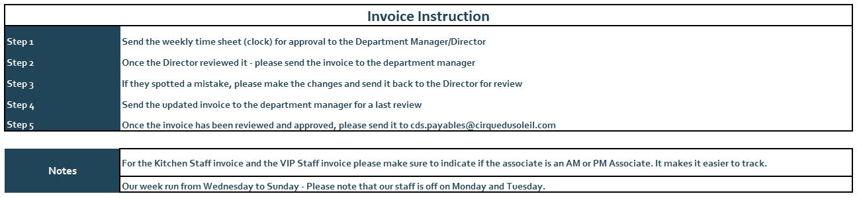

Exhibit C

tour plan

Supplier understands and agrees that the Market listed in the Tour Plan only indicates the geographic location where Cirque intends to present the Show and that the Show may be presented in the vicinity of any given Market of the Tour Plan. The dates and corresponding Markets are subject to change at any time.
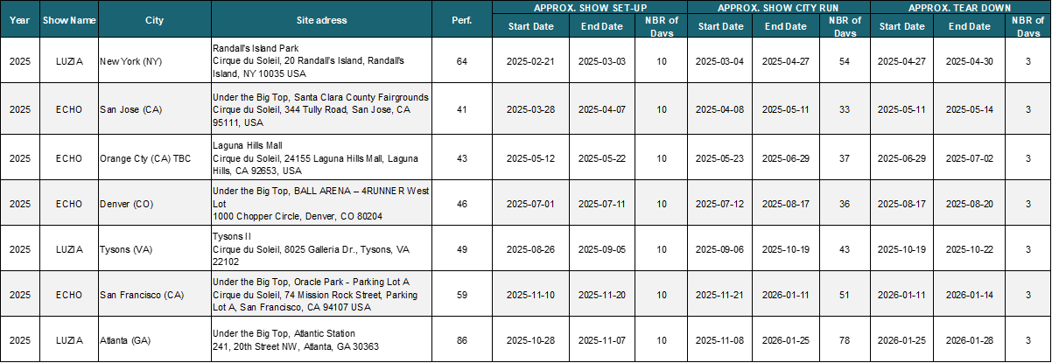

Exhibit D

GENERAL CONDITIONS & STAFFING REQUIREMENT
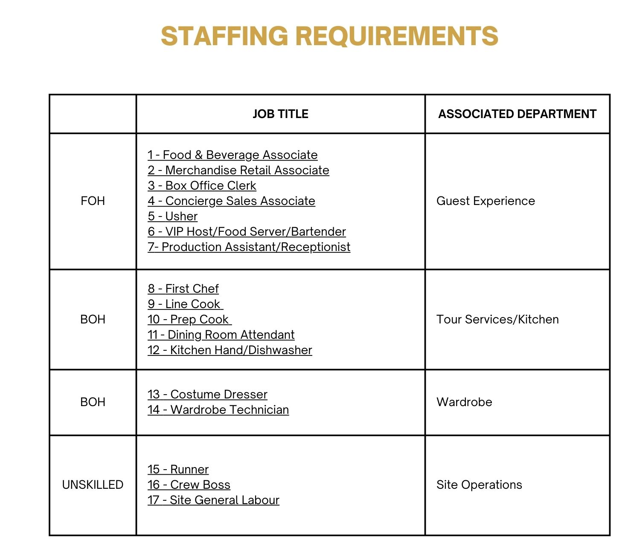

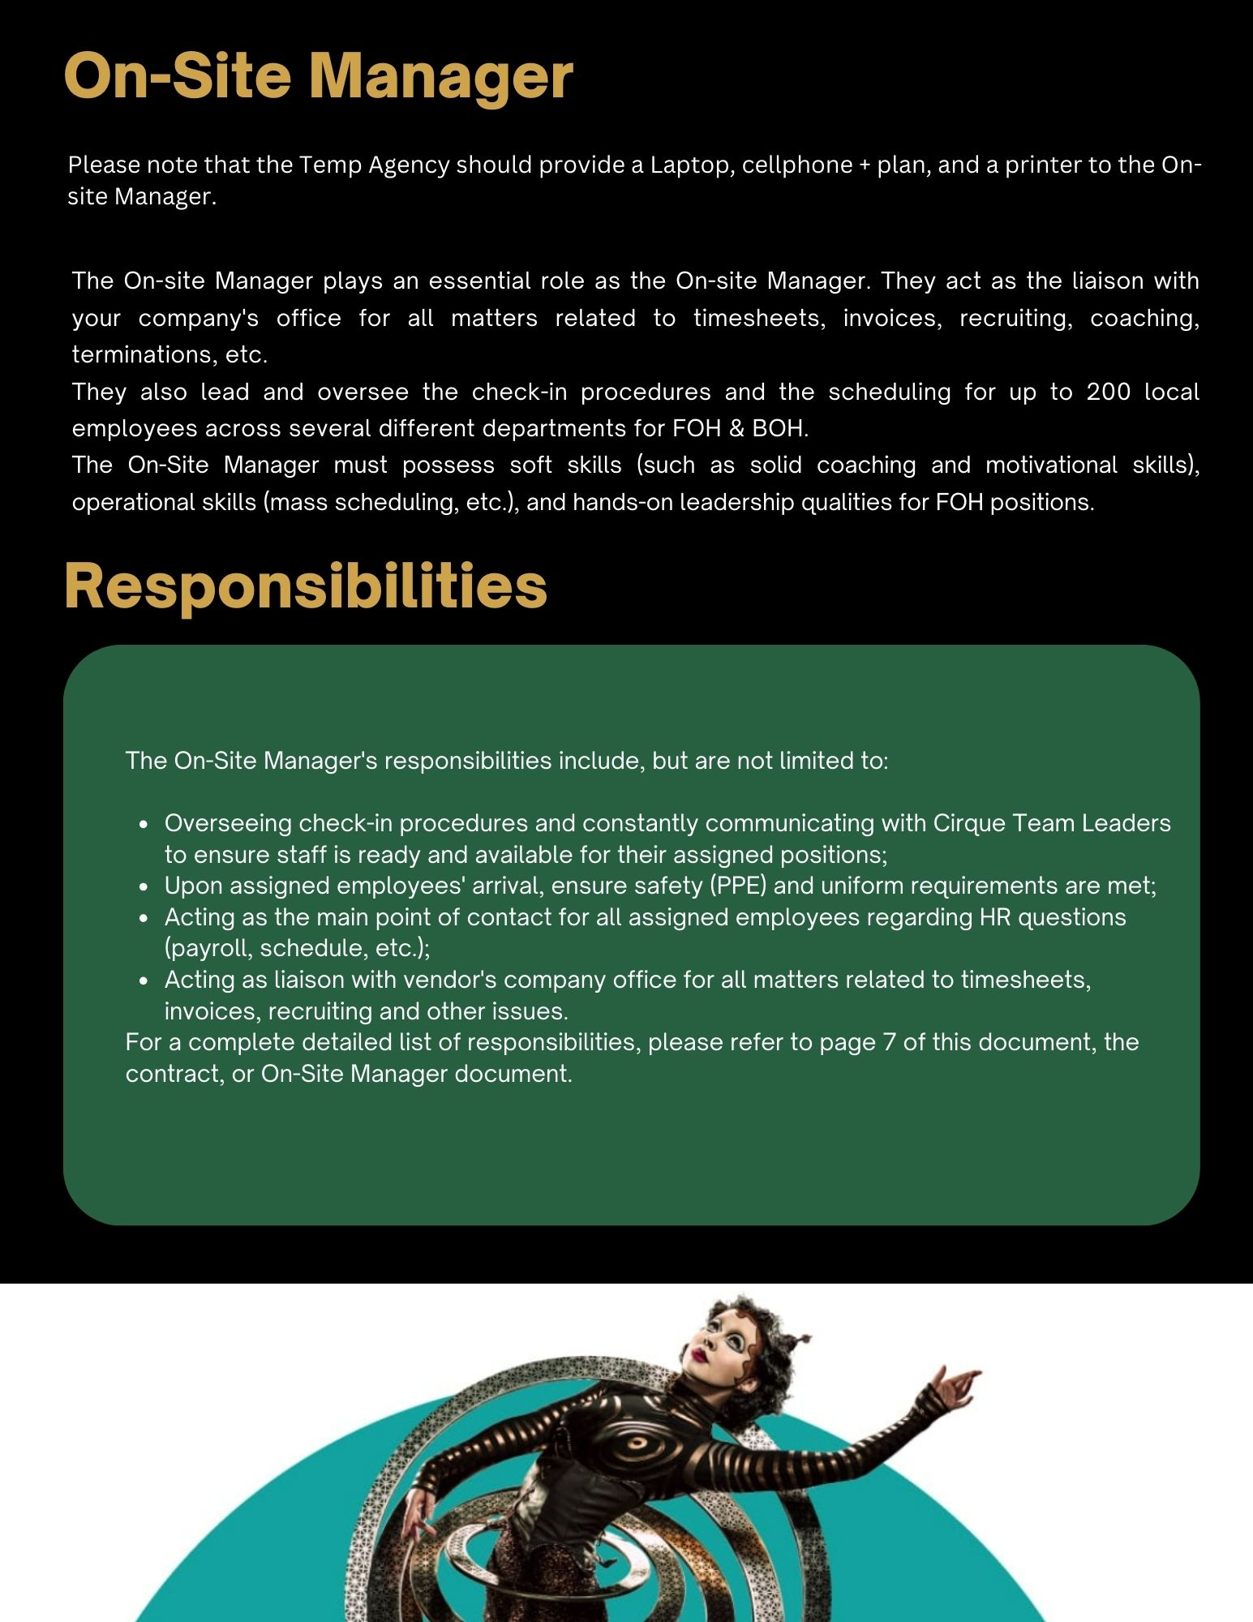
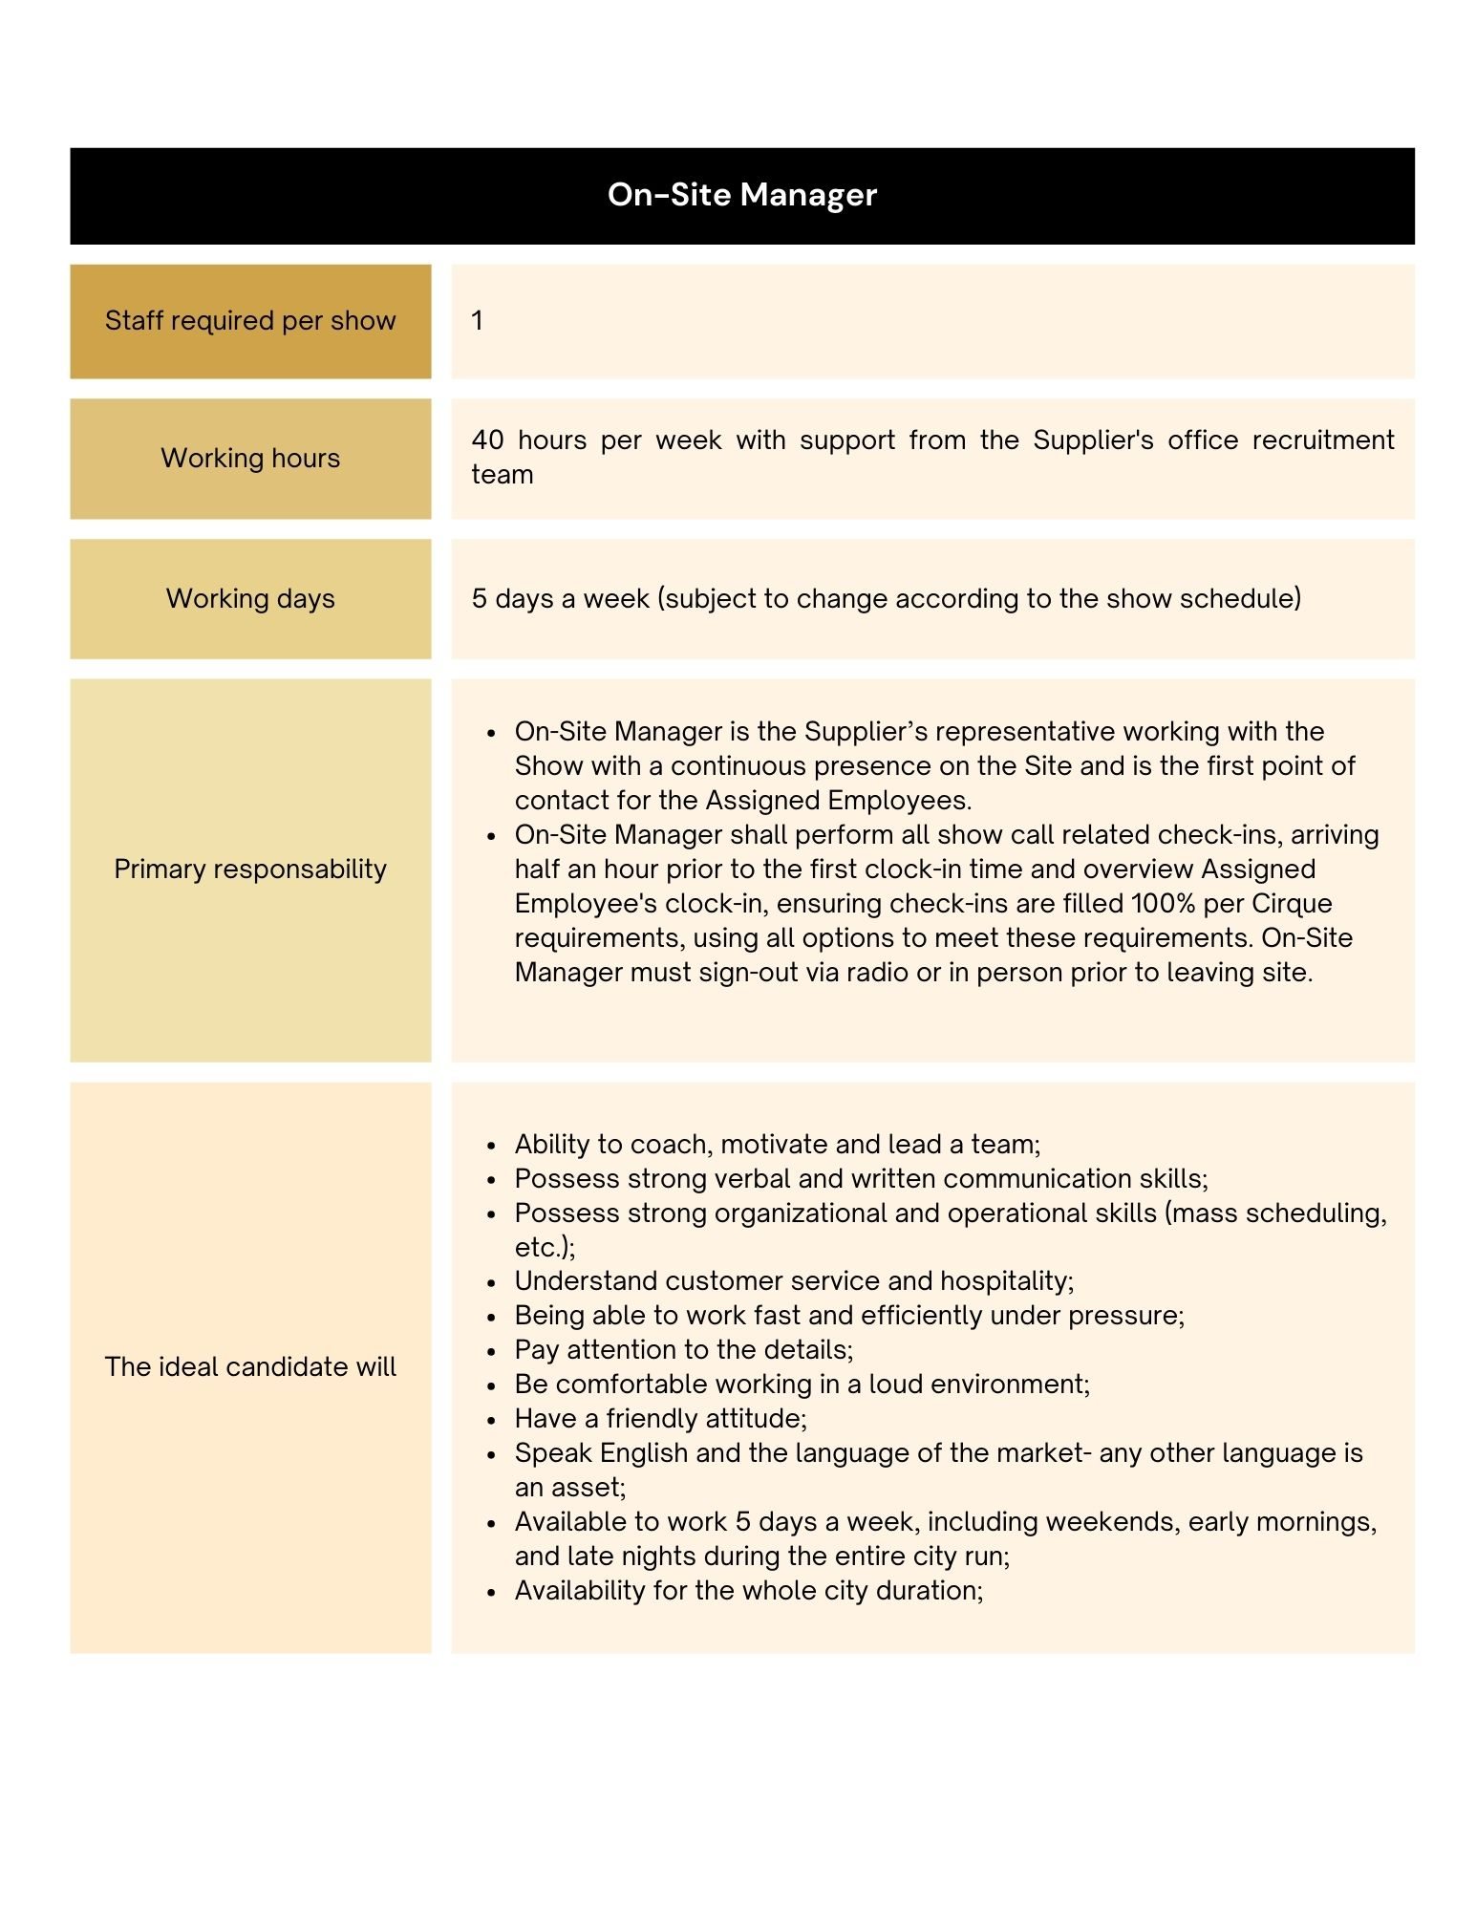
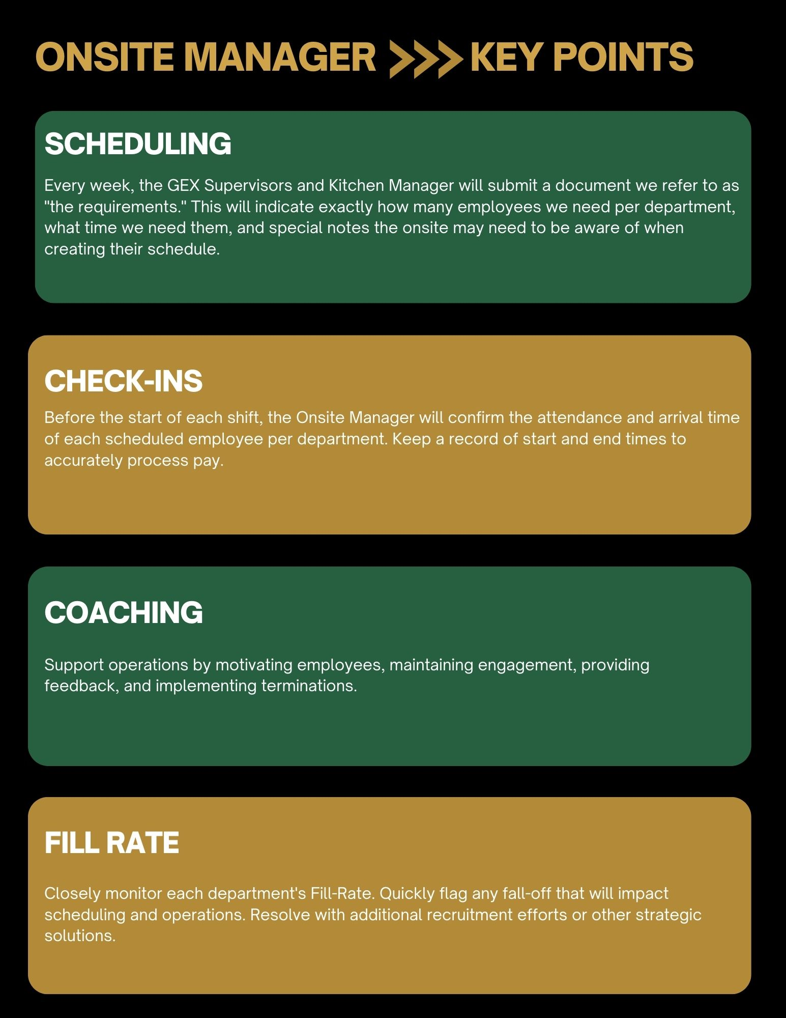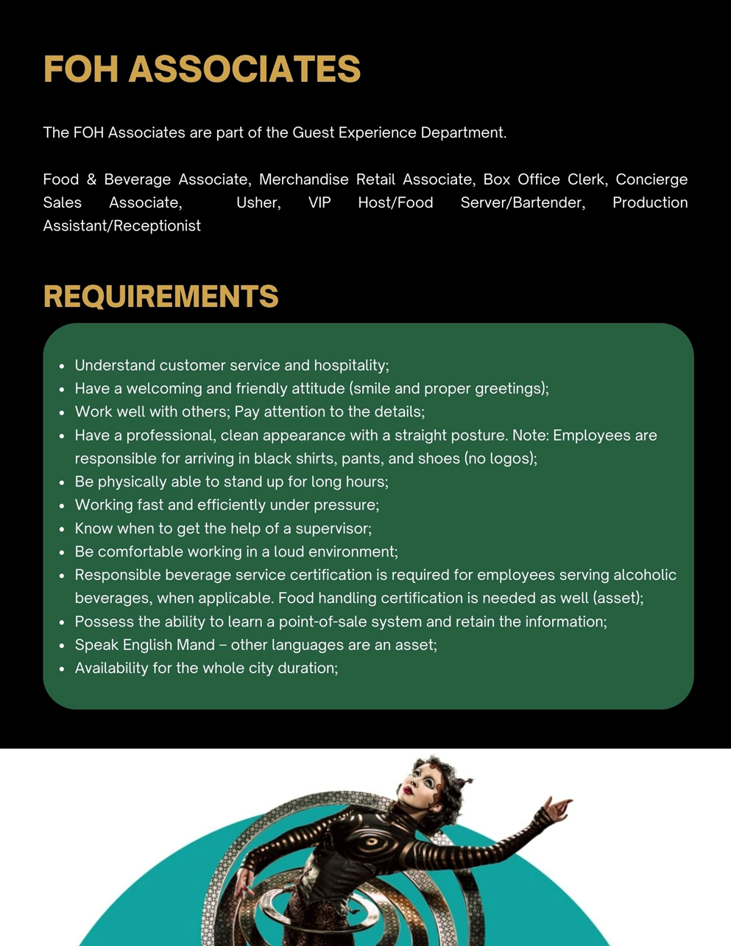

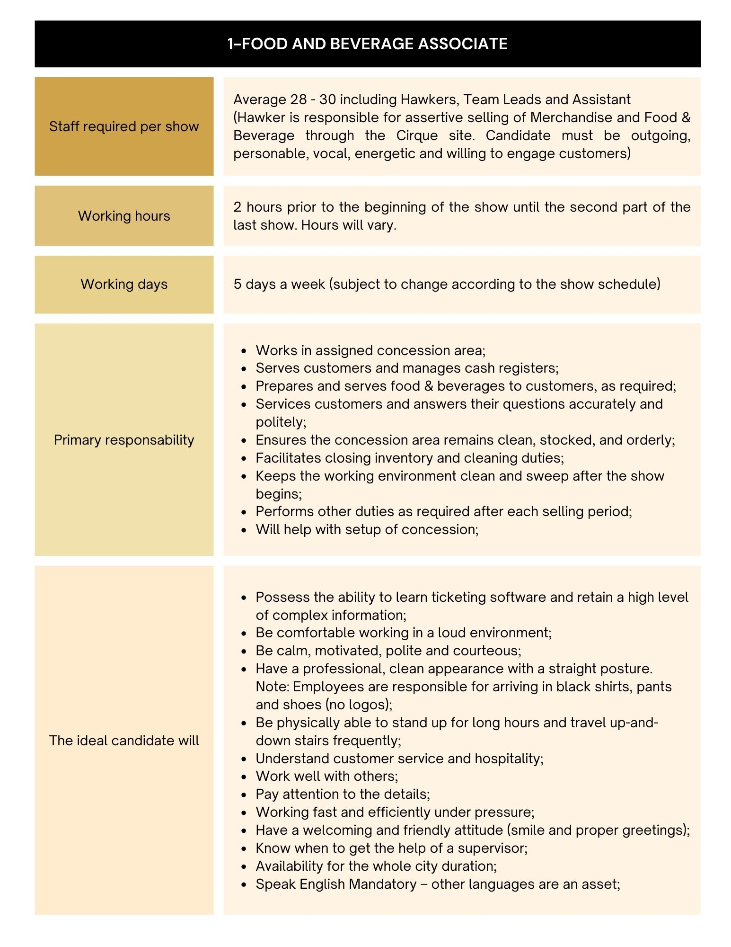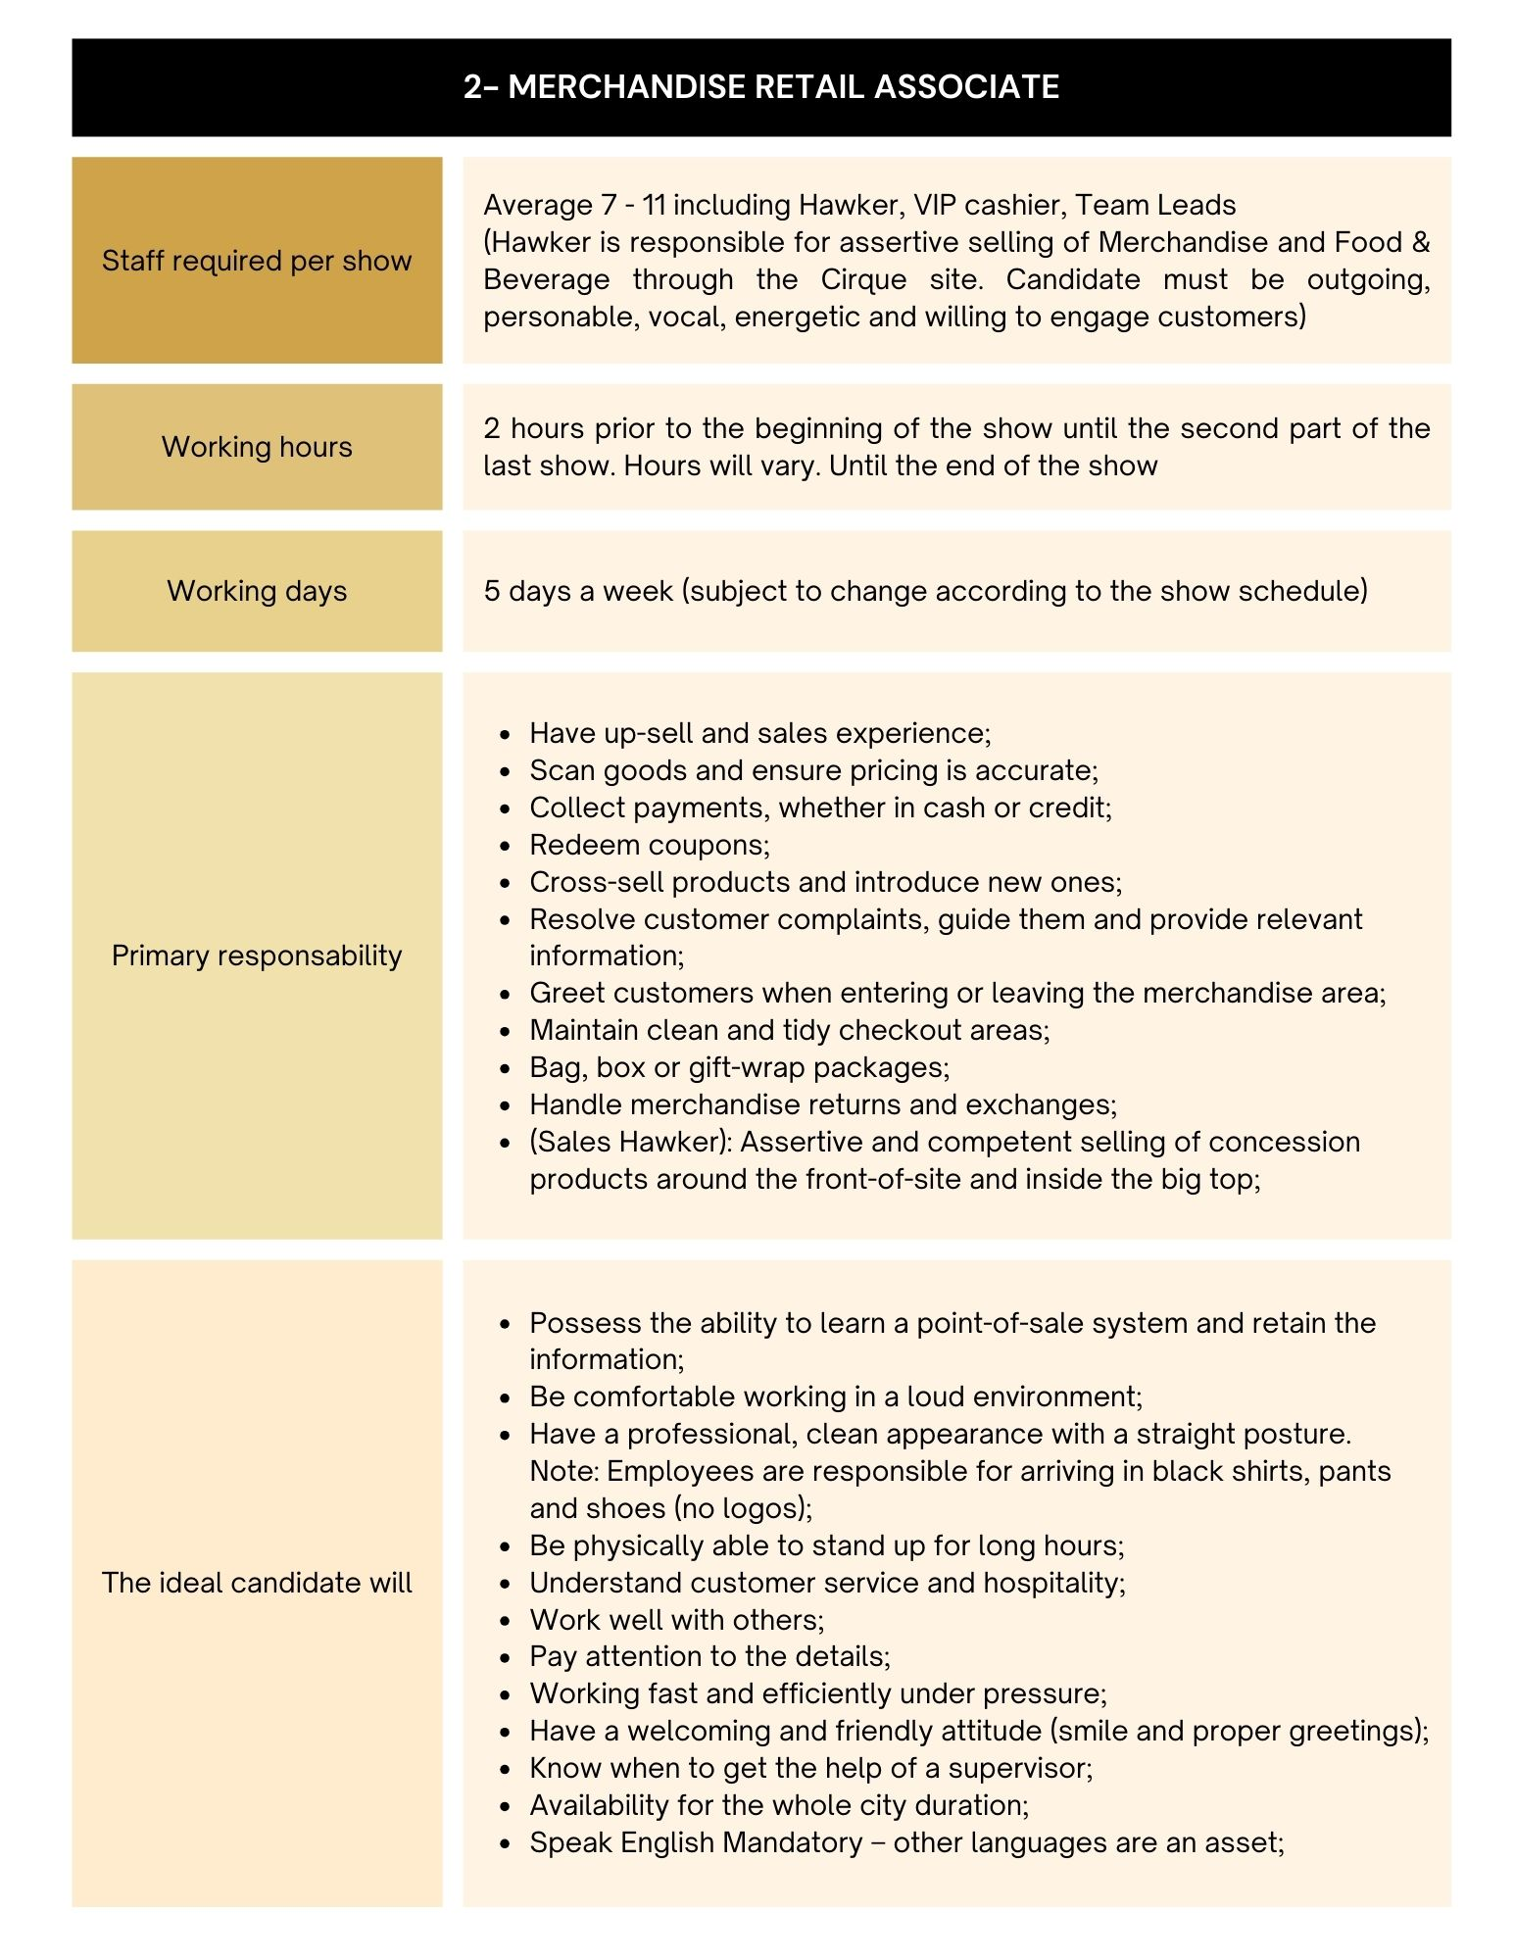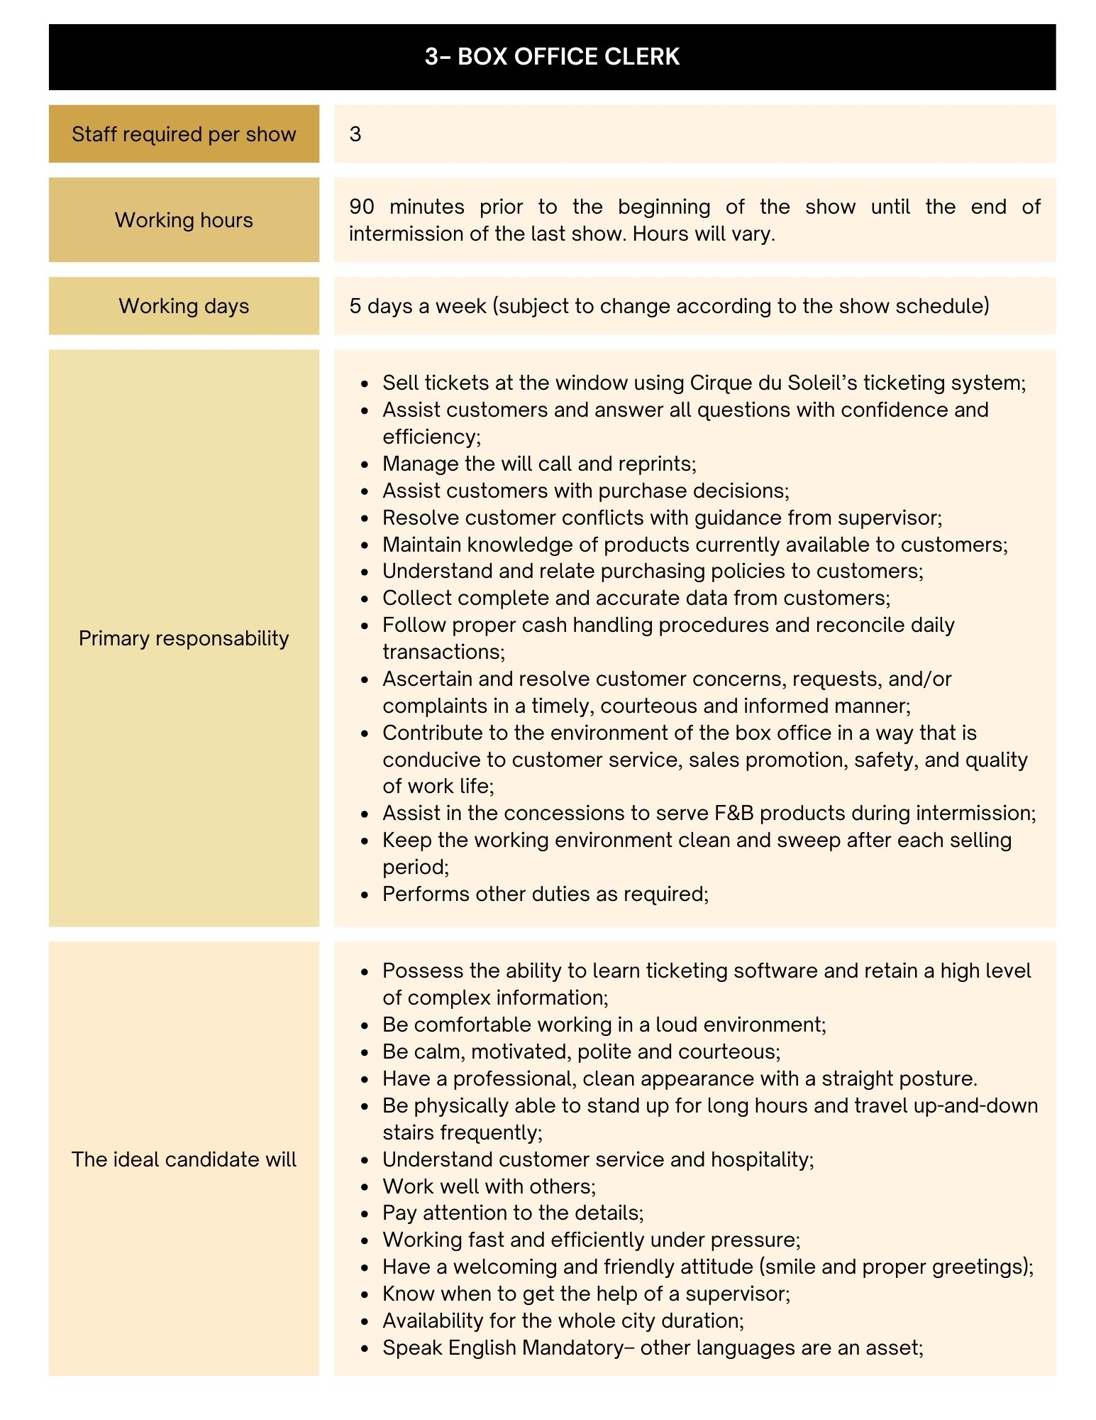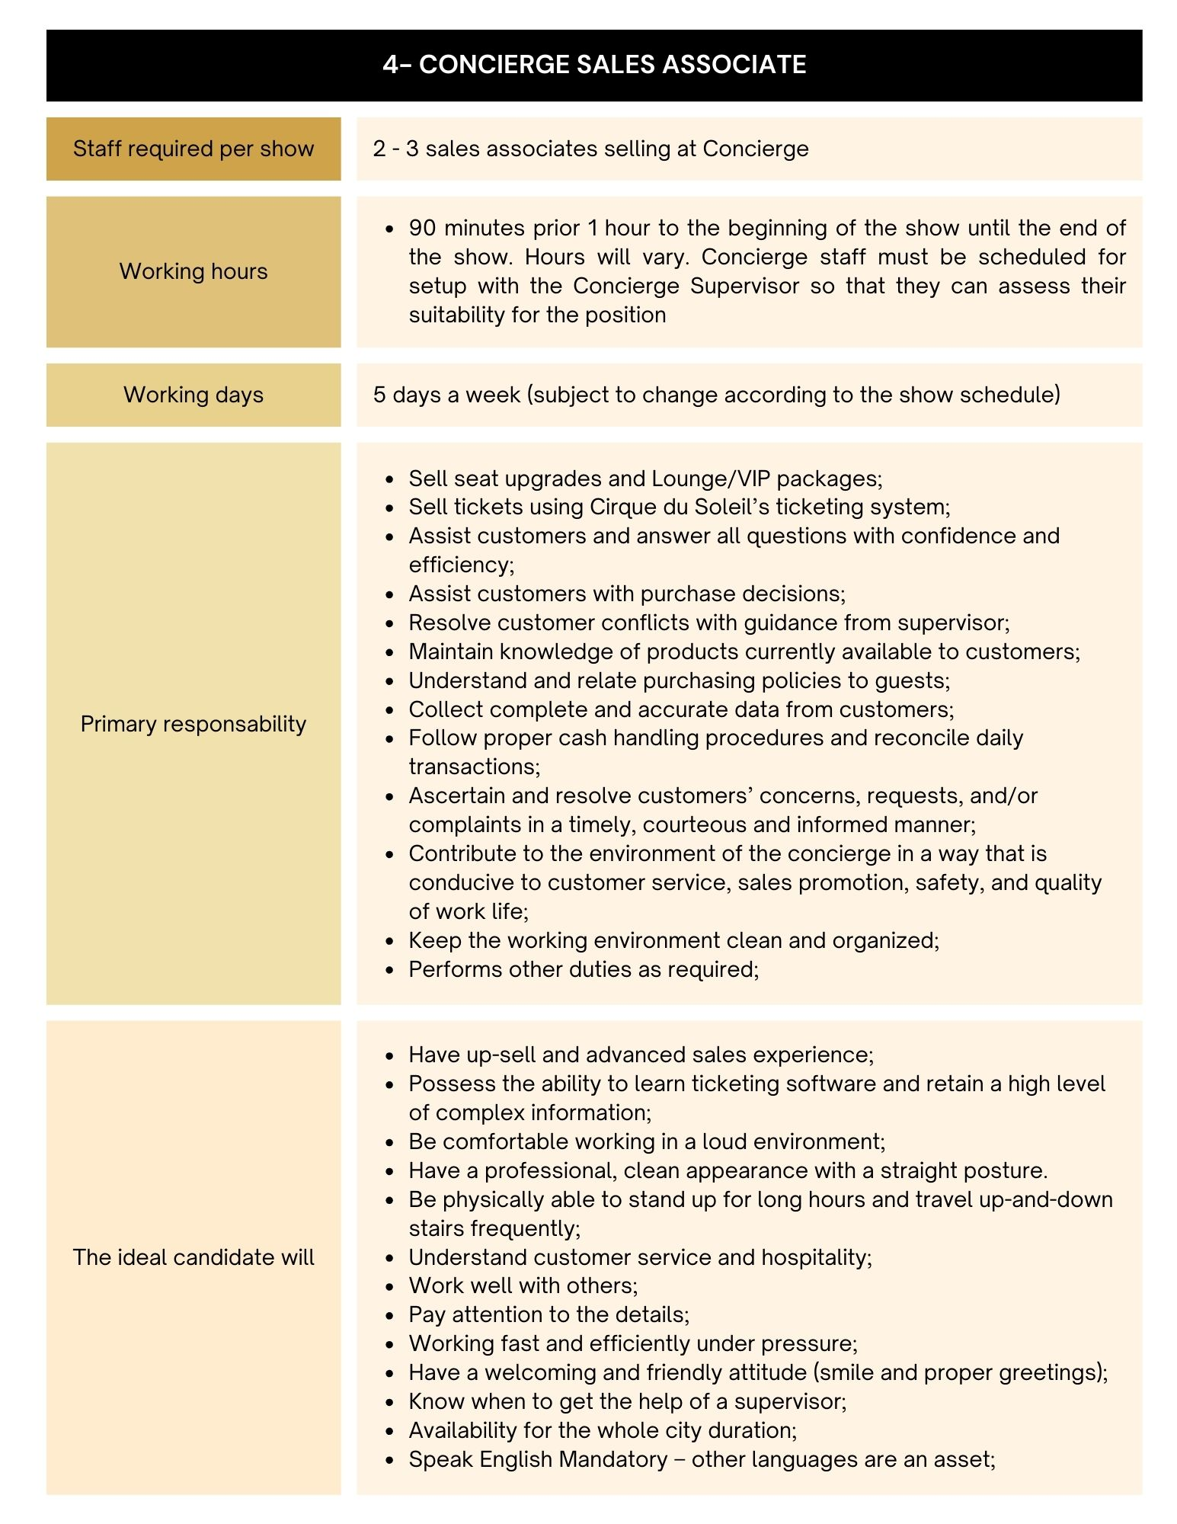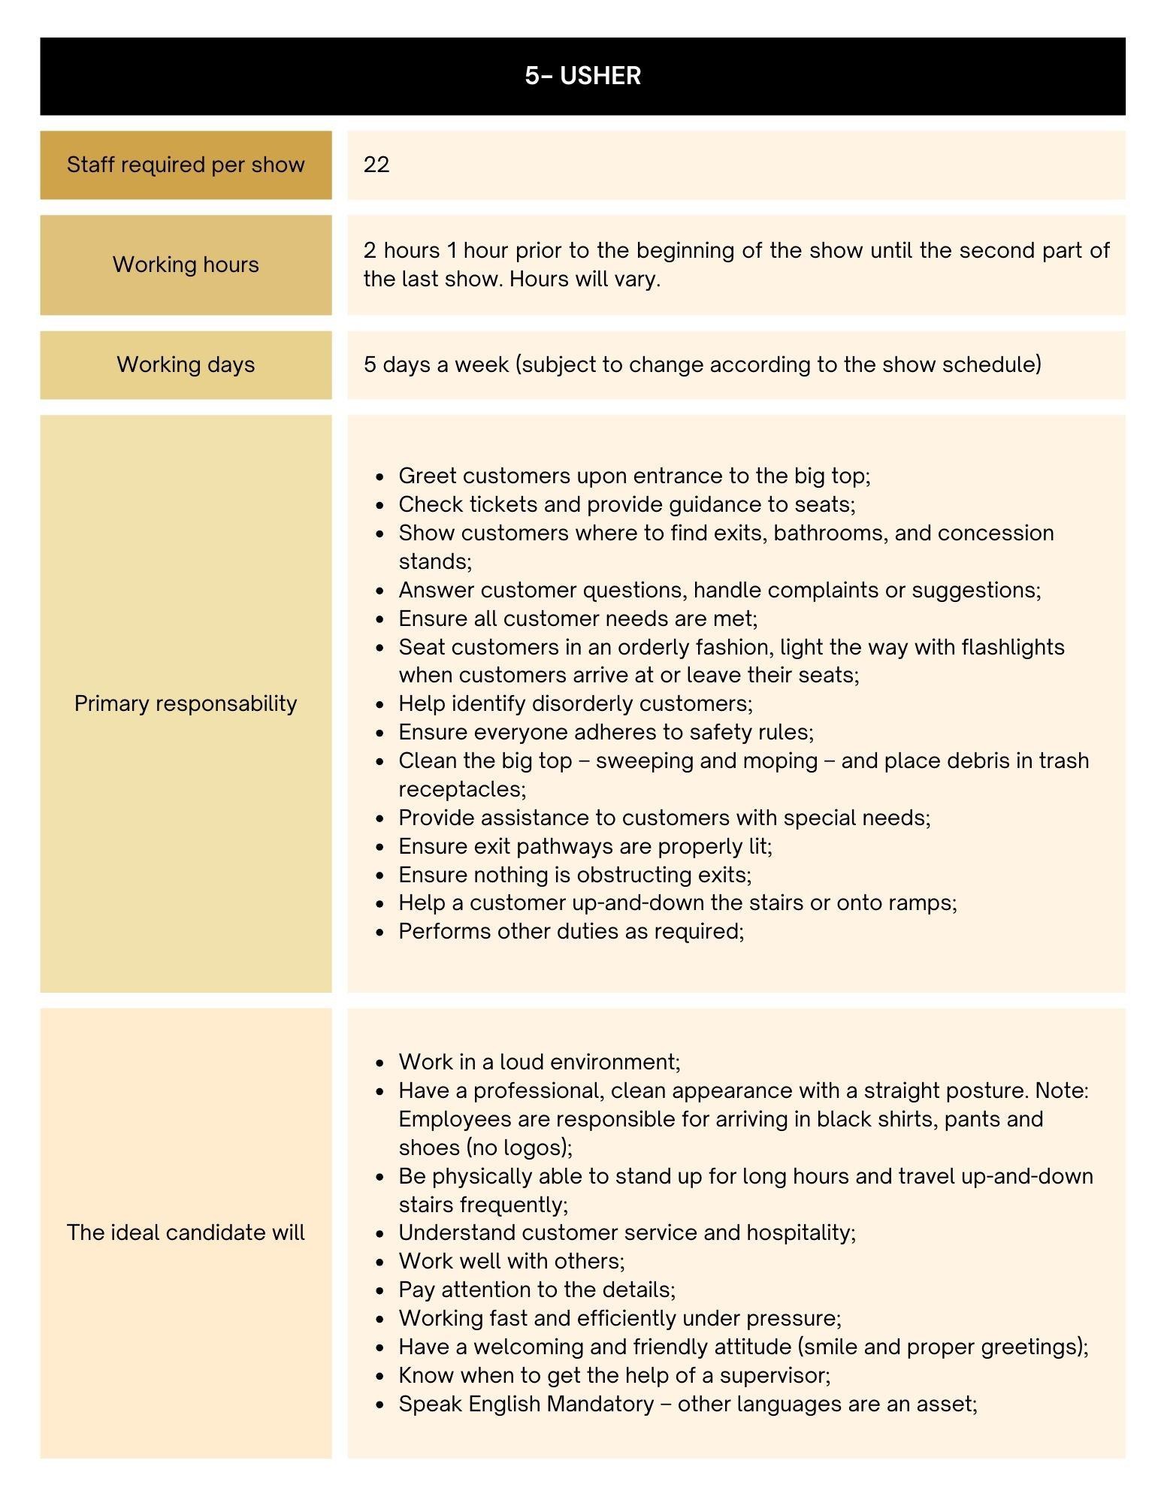

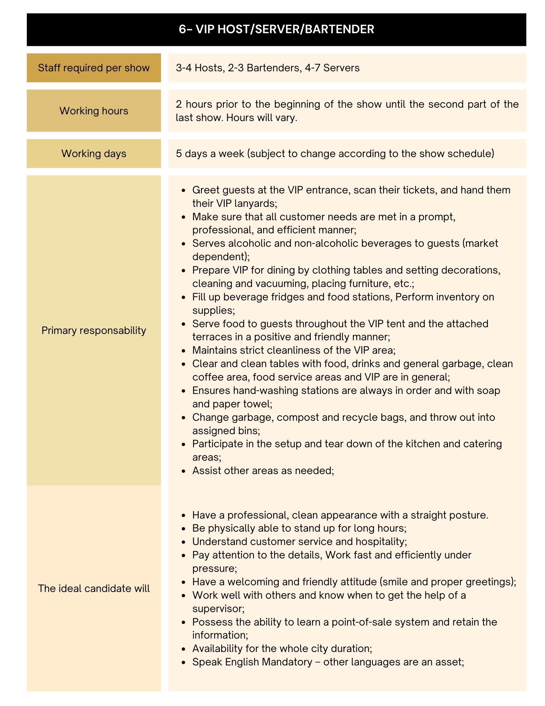

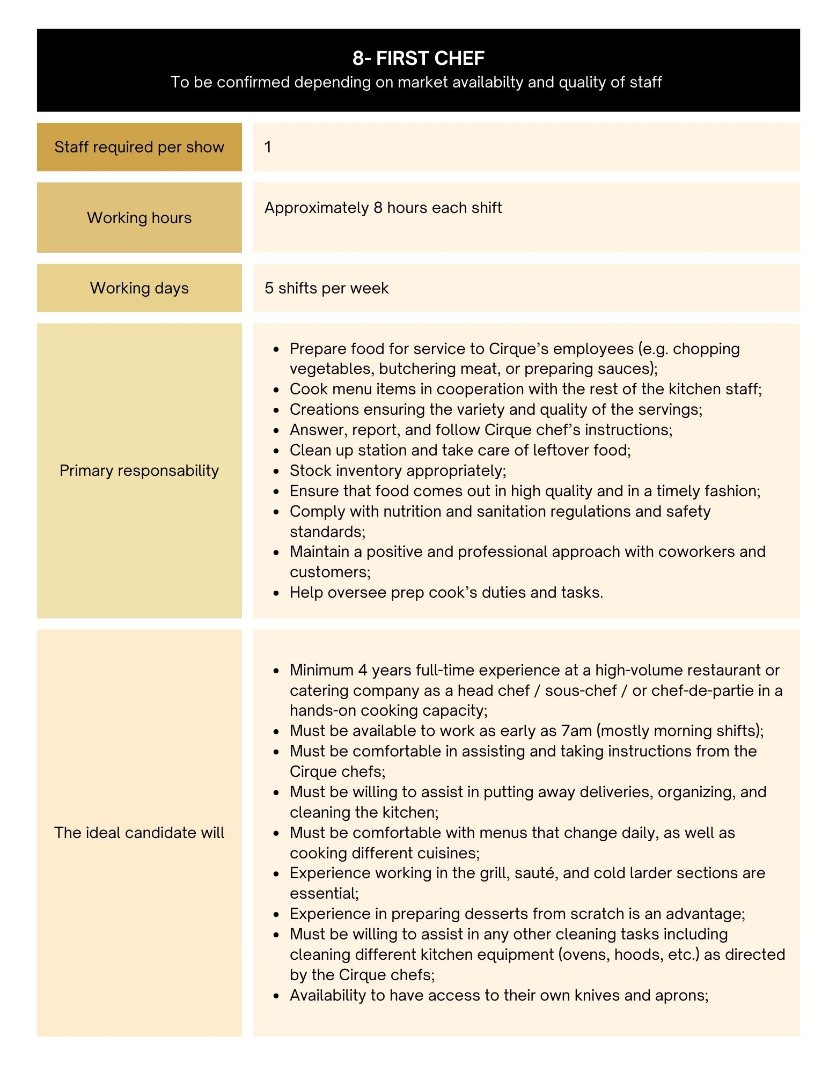
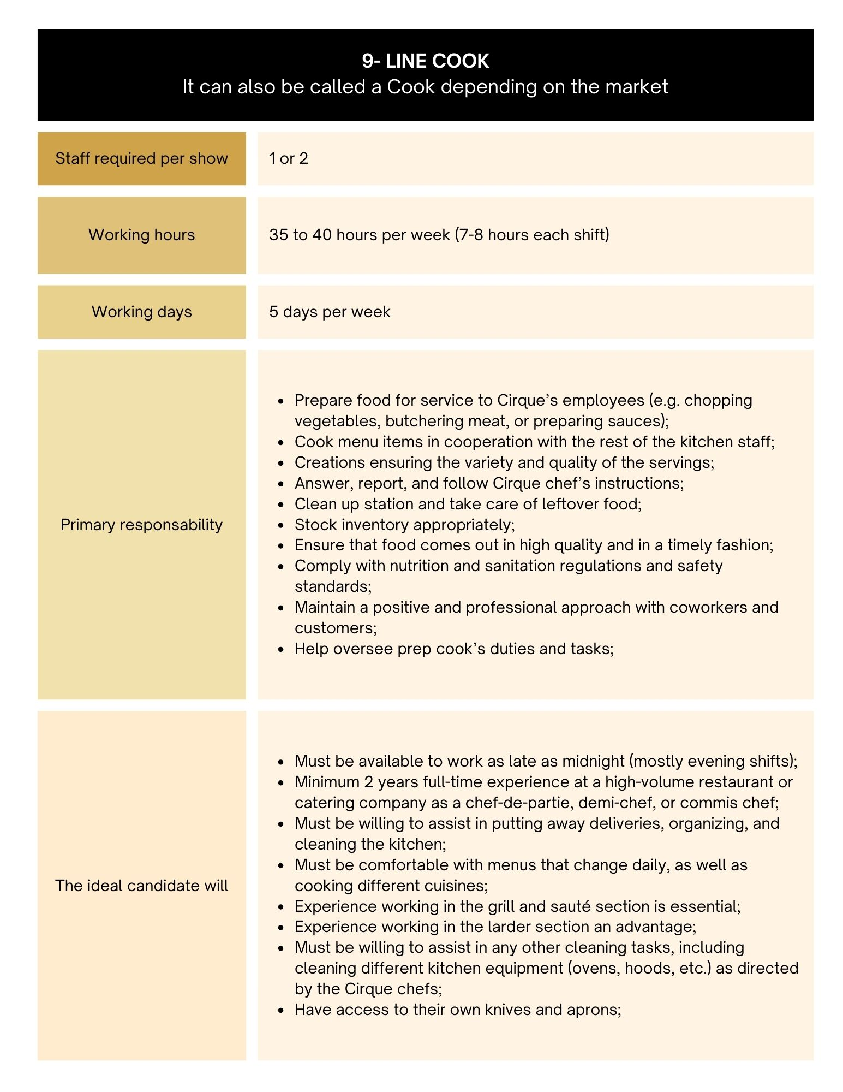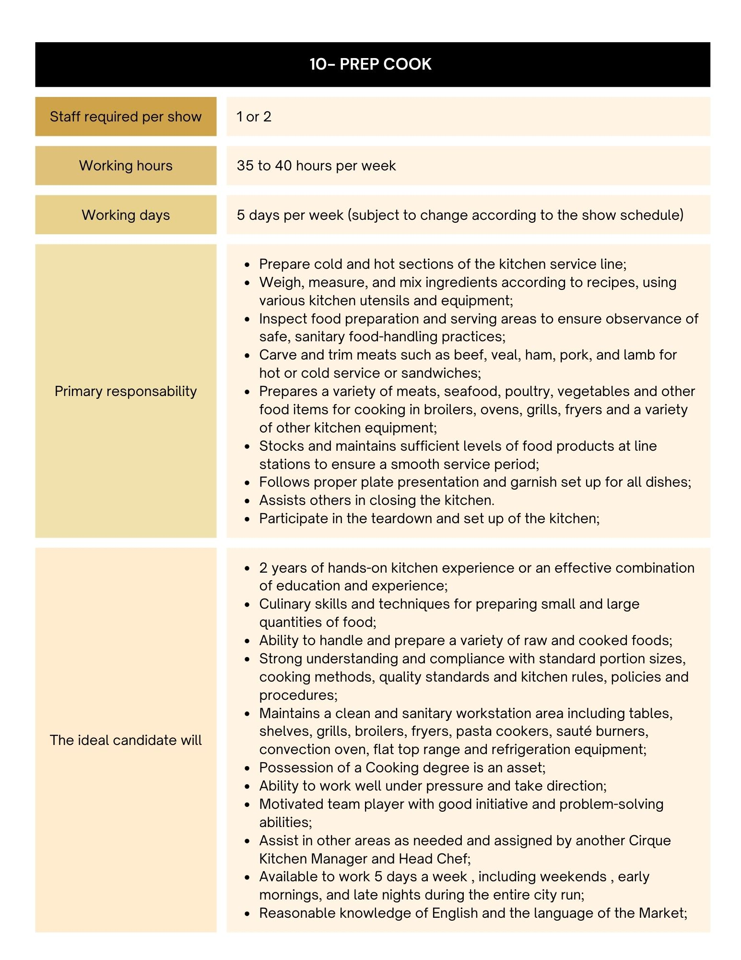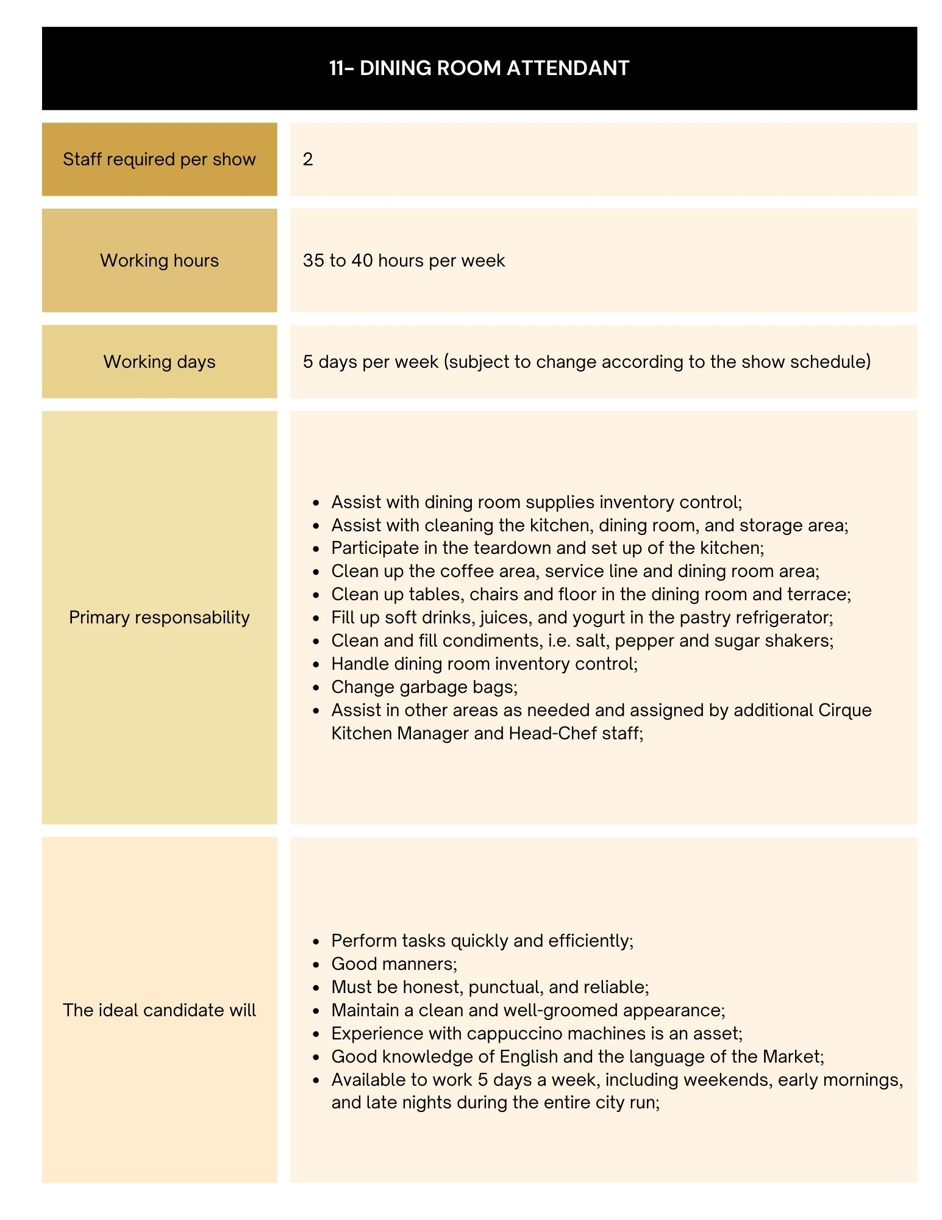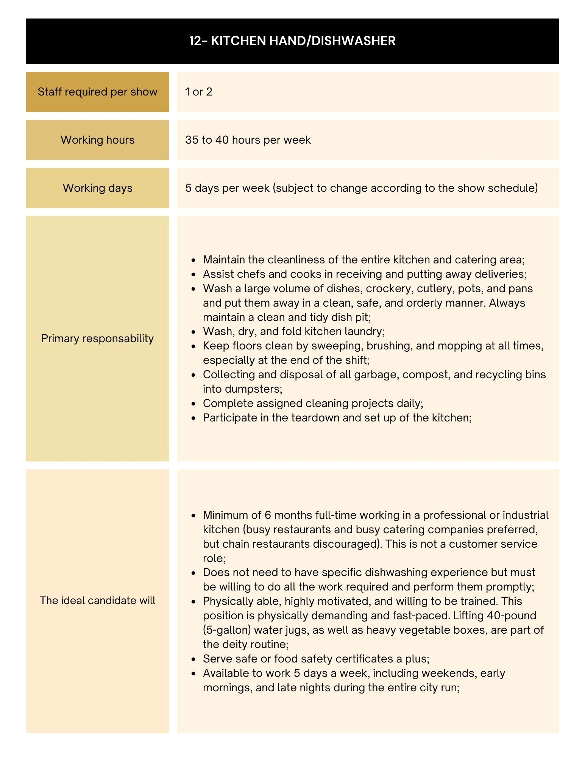



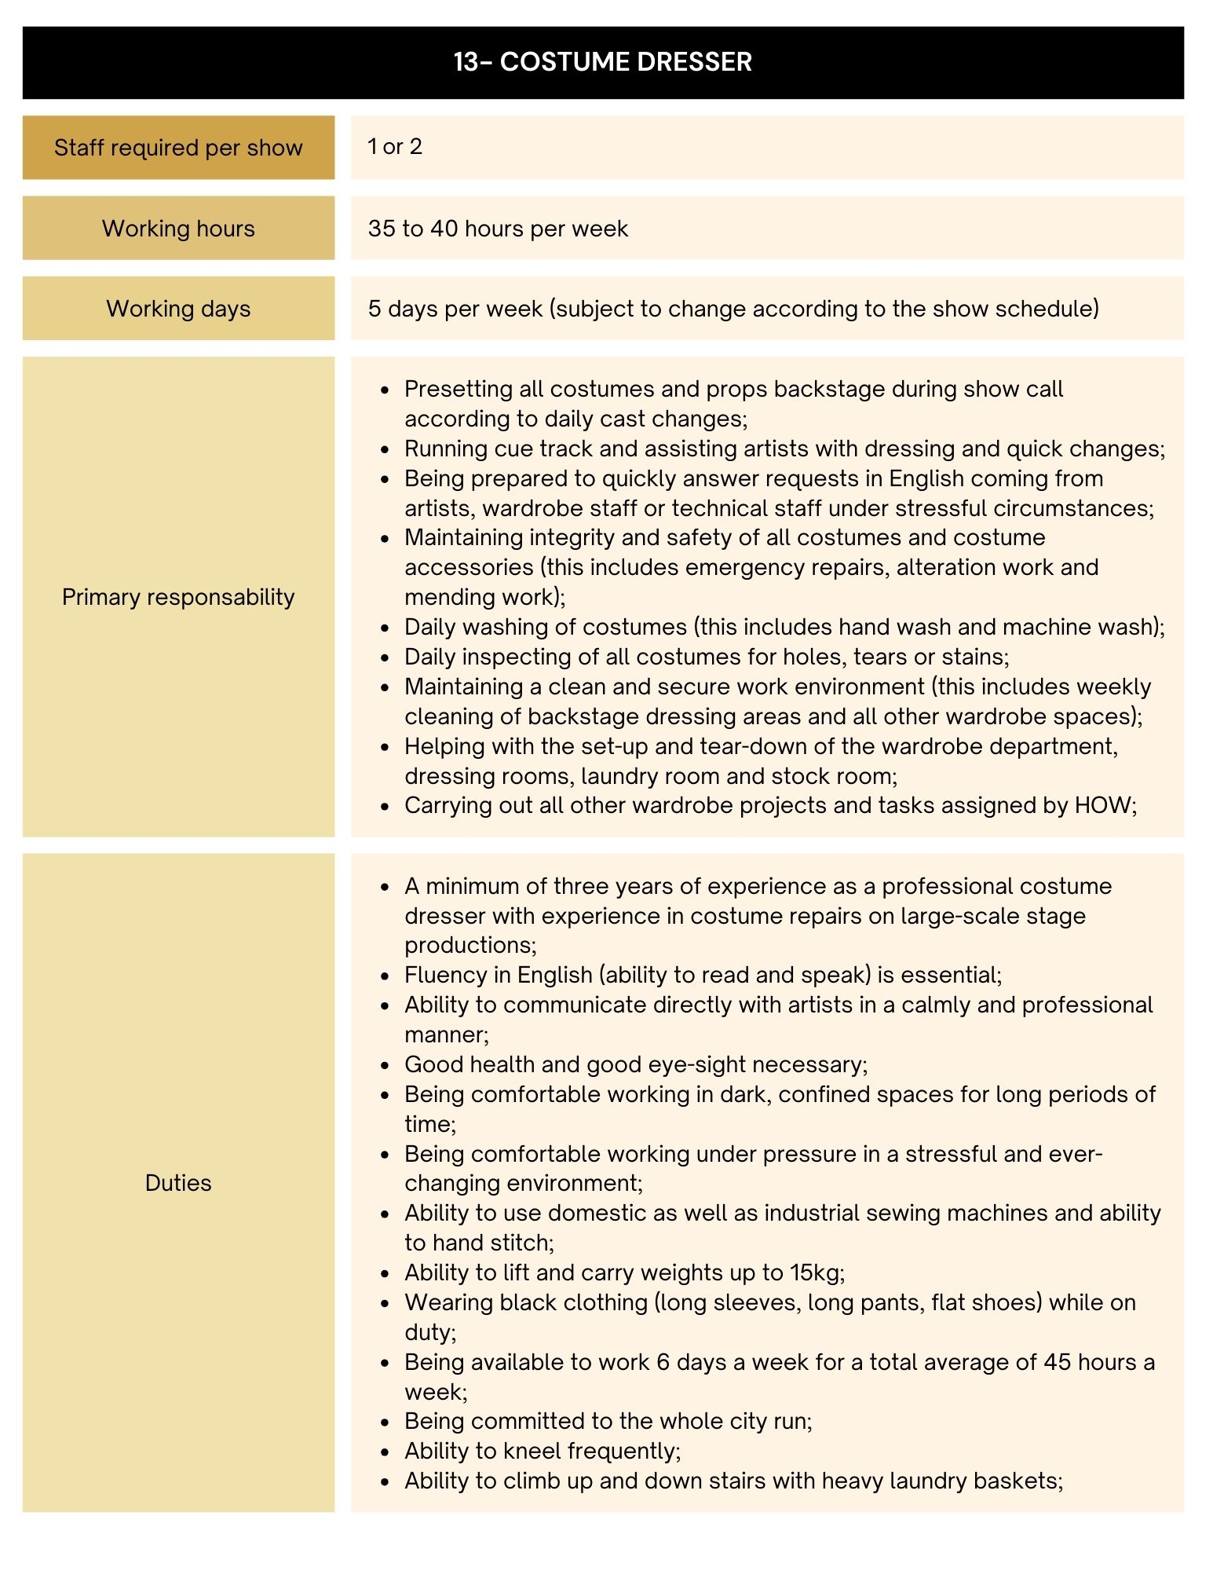
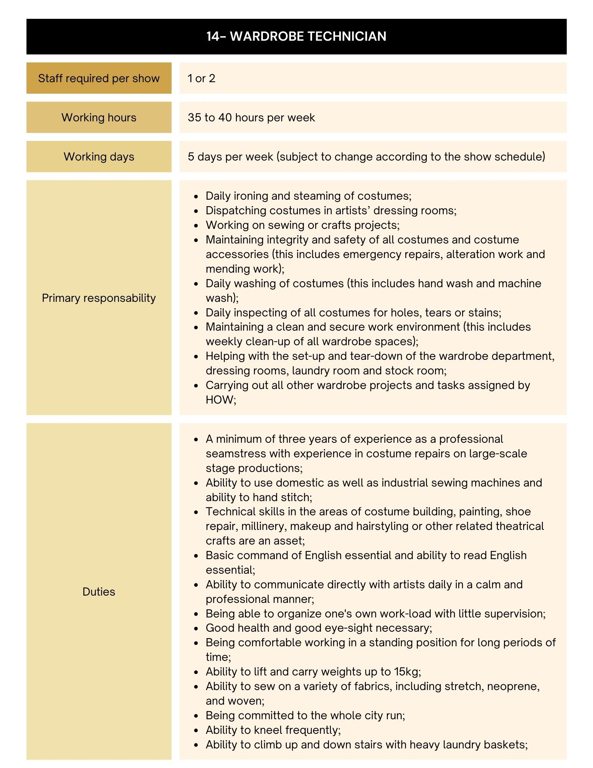

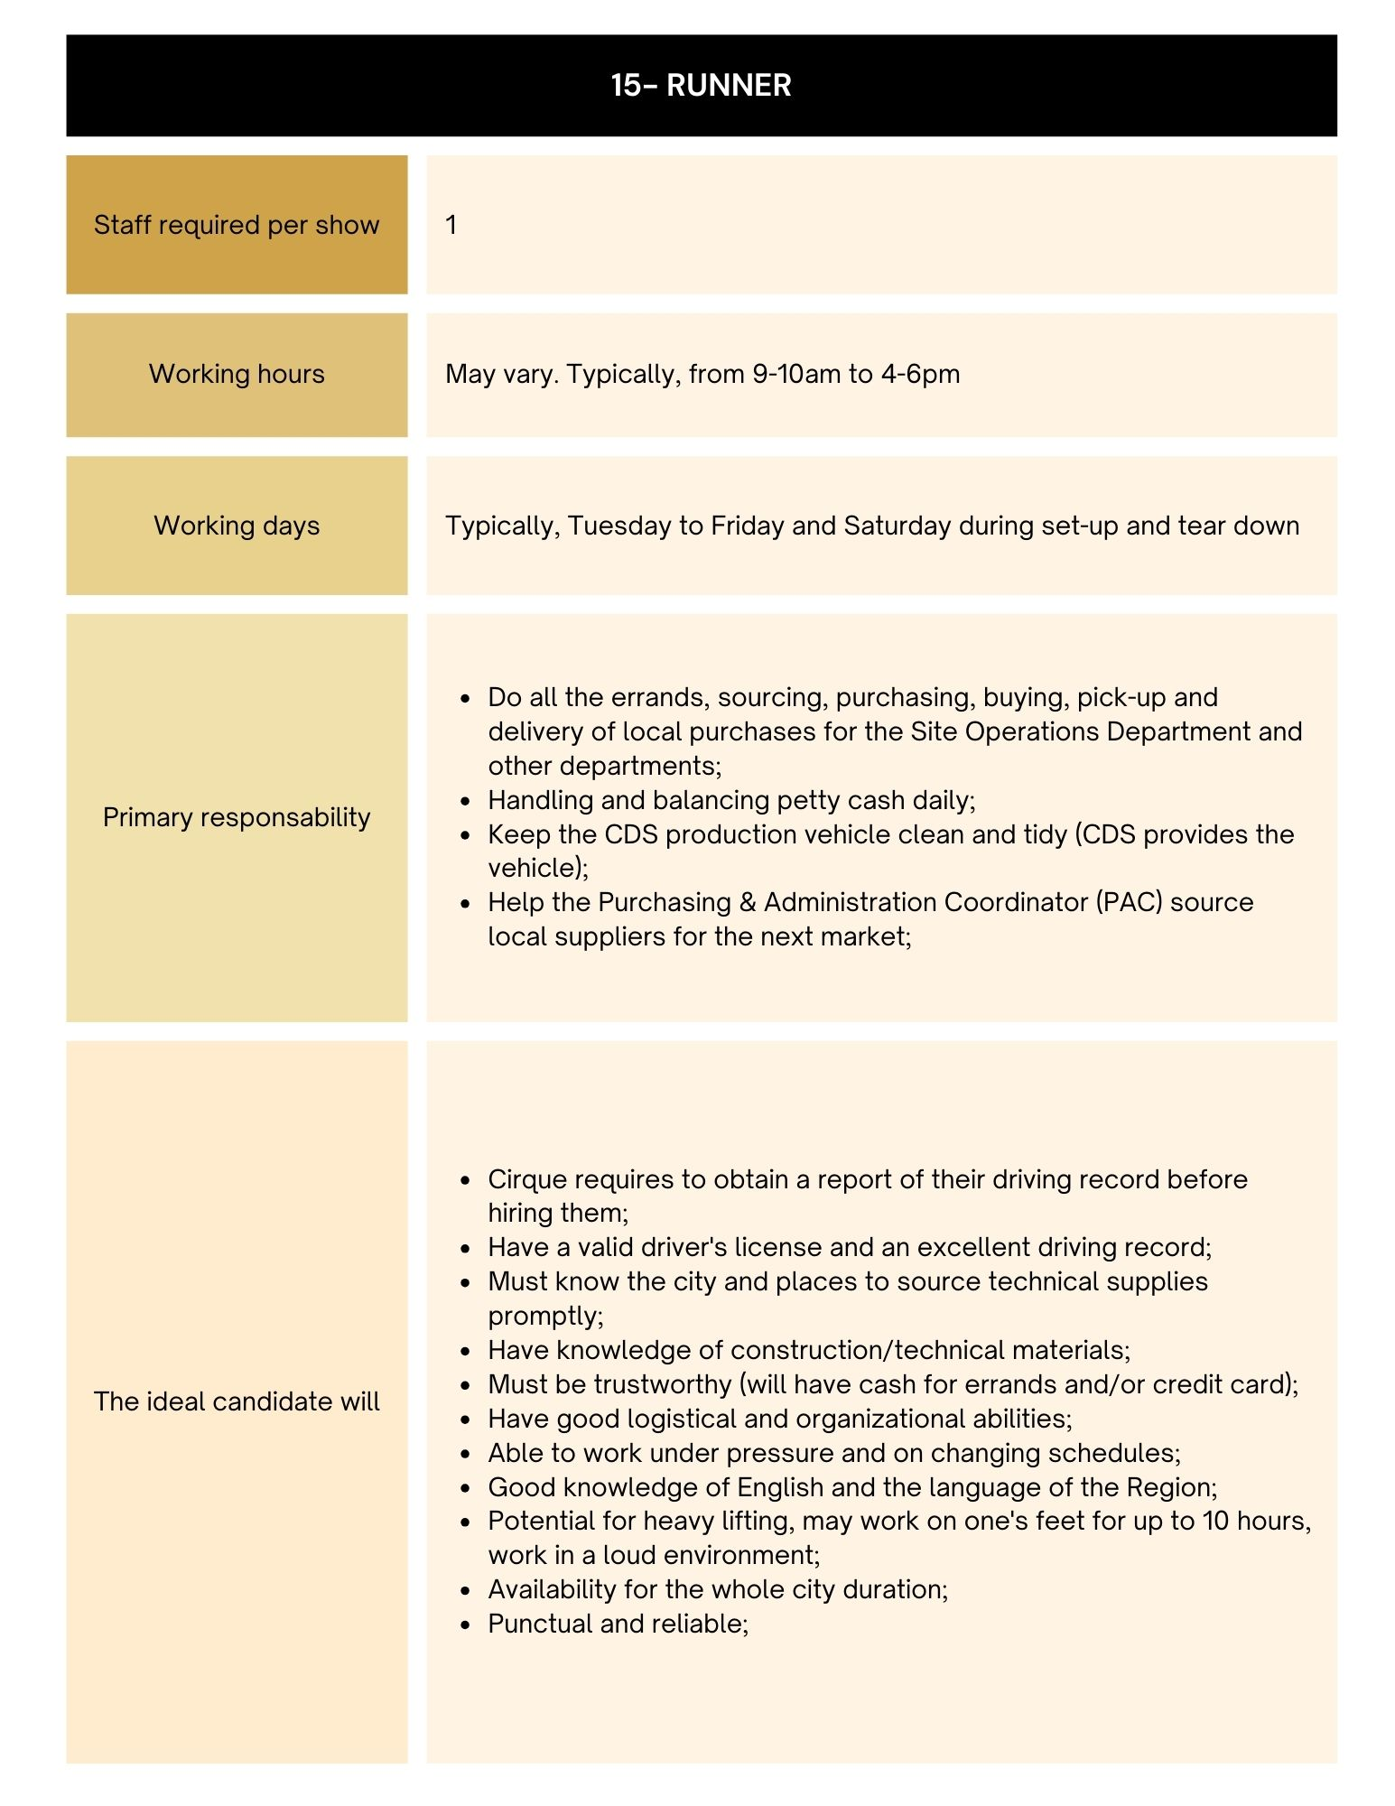

RECRUITMENT AND MANAGEMENT PROCEDURE

        - RECRUITMENT AND SELECTION OF ASSIGNED EMPLOYEES
          - Pre-Selection Requirements
Supplier shall be responsible for the pre-selection of all Assigned Employees for each Market. During the pre-selection, Supplier shall: (i) verify the identity and the employment eligibility for all Assigned Employees; and (ii) when requested by Cirque and allowed by national law, check a minimum of one (1) reference per candidate to ensure that the potential candidates possess the minimum skills and experience for the job profile as set forth herein.
          - Interviews
Supplier will recruit, screen, interview, select and hire Assigned Employees who shall have the skills and experience defined for each job category as set forth herein. Cirque shall have the right to interview potential Assigned Employees suggested by Supplier for any job profiles. Cirque shall be responsible for making the required arrangement with Supplier in order to set-up the appointments with such potential Assigned Employee. Supplier shall provide to Cirque the names of the potential candidates two (2) calendar days prior to the date of the interview, along with resumes and other evaluation documents, to the extent permitted by applicable law, that may be requested by the hiring department. Notwithstanding the forgoing Company shall only interview potential Assigned Employees to determine if the skills and experience of Assigned Employees match the requirements requested by Company. Company shall have the right to refuse any Assigned Employees they are not satisfied with pursuant to section 1.4 below and for law reason only. Supplier shall provide, at no cost to Cirque, the facilities to be used for the interviews between Cirque and the potential candidates. Further to such interviews, Cirque may reject any potential Assigned Employees and supplier shall suggest other candidates.
          - Criminal background check and other verifications
Company shall provide the screening criteria for the position to fill and be responsible to ensure such criteria are job-related and consistent with business necessity. Suppliers shall not assign any Employees who do not meet Company’s lawful criteria. Supplier shall conduct a criminal background check and other verifications with former employers and/or appropriate governmental organizations during the recruitment of Assigned Employees for:
- any Assigned Employees which shall be entrusted with cash, checks, keys, credit cards, merchandise, negotiable instruments or other valuables (specifically, Runner, box office clerk, merchandising clerk, F&B clerk, dining room attendant);
- any Assigned Employees who shall use any vehicle, regardless of ownership, in connection with the performance of Services to Cirque (specifically, runner).
Supplier acknowledges that such criminal background and other verifications must be imperatively completed and a written attestation of completion provided to Cirque’s Show Operations Director before the Assigned Employee starts his/her first day of assignment.
No extra cost will be charged to Cirque for such verifications. Cirque understands that in some territories, such verifications are not allowed by law.
To preserve the Assigned Employees privacy rights, the parties agree that Supplier shall not be required to disclose information contained in the personnel, medical leave, or other confidential files (if any) of Suppliers Assigned Employees to Company unless such disclosure is: (a) necessary to comply with either party’s legal obligations; (b) necessary to comply with the terms of this Agreement; (c) related to an incident or (d) is ordered by administrative, arbitral, or judicial tribunal. Additionally, if an Assigned Employee fails a background or drug screening (for example hard drugs), Supplier will not disclose such failure to Company nor will Supplier provide such Assigned Employee for services with Company. If a currently placed Assigned Employee fails a background check or drug screening requiring the ending of such Assignee Employee’s placement with Company, Supplier shall only disclose to Company that the Assigned Worker is being removed from assignment to be replaced. Company is not to request or have knowledge that Supplier’s Assigned Worker has failed the background check or drug screening and, and Supplier will not disclose or discuss the background check or drug, or other such screening was failed with Company.
          - Rejected Potential Assigned Employee & Minimum Work Day
Company agrees to a daily minimum charge of three (3) hours. If Company fails to cancel any order at least two (2) hours prior to the assignment start time, Company will pay the daily minimum charge for each Associate

A potential Assigned Employee who has not been accepted by Cirque for a job profile may be proposed to Cirque by Supplier for another job profile unless otherwise specified by Cirque. To the extent such information has been made available to Supplier, and Supplier possesses the technological capabilities for the maintenance of such information system, Supplier will use reasonable efforts to not submit to Cirque a potential Assigned Employees that has been dismissed on another Cirque show. Cirque shall notify Supplier of its dissatisfaction and Supplier shall immediately remove the Assigned Employee from the assignment and, if requested by Cirque, replace such Assigned Employee by another employee within a reasonable delay.

In the event Cirque notifies Supplier of its dissatisfaction during the first two (2) hours of the assignment for General Labour and four (4) for FOH and BOH, Cirque shall not be required to make any payment to Supplier for the first four (4) hours worked by such Assigned Employee whose assignment has been terminated for the reason set forth above.
          - Last Minute Job Orders:
Supplier shall handle all Assigned Employees requests made by Cirque after the expiration of the delay set forth in Section 1.2 of the Agreement (hereinafter the “Last Minute Job Orders”). Outlined below is the standard response time, from order placement, by which supplier shall update Cirque regarding its requests in respect to Last Minute Job Orders only:
            - Same day job orders: 30-minute call back
            - Next day job orders: 1-hour call back
            - Temp-to-Hire orders: typically, a 2-hour call back
          - Supplier shall keep Cirque informed on the status of the recruitment and selection process in accordance with the Market Preparation set forth below.
          - Prior to the placement of the Assigned Employees, Supplier shall comply with all necessary laws and regulations with respect to the Assigned Employees.

        - ASSIGNMENT OF ASSIGNED EMPLOYEES
No later than the first day of the assignment, Supplier shall provide to Cirque the names of the Assigned Employees and, for identification purposes, .jpg format photos. All Assigned Employees will need a photo ID in order to enter and work on the show site.
          - Cirque Rules and Policies
Supplier shall be responsible to generally instruct all Assigned Employees, before the first day of assignment, with regard to the duties, responsibilities, working conditions, health and safety Guidelines, standards, practices and policies of Cirque as advised/and or contained within documents to be provided by Cirque to Supplier, including, without limitation, Cirque’s house rules and policies, provided that such house rules and policies may be changed from time to time by Cirque, at its reasonable discretion. Cirque shall provide Supplier with the necessary information in order for Supplier to provide the Assigned Employees with the above-mentioned instructions in advance. Supplier acknowledges that the time required hereunder for Assigned Employees’ awareness of Cirque house rules and policies shall be at the cost and expense of Supplier. Company and / or Cirque shall be responsible for all site-specific training required.
Supplier shall use its best efforts to ensure that during each assignment, the Assigned Employees respect any and all legal provisions and regulations as well as any and all standards, practices and policies established from time to time by Cirque.
          - File Keeping
Supplier shall be responsible for keeping proper files on each Assigned Employee, as required by law.
          - Complaints, Claims and Proceedings
Each Party agrees to cooperate reasonably and to provide reasonable assistance to the other Party in the investigation and resolution of any complaints, claims, actions, or proceedings which may be brought by or involve any Assigned Employee.

        - SUPPLIER’S ON-SITE

Supplier will provide a local branch employee on-site when available for check in, check out and liaison with associates. The local branch employee is the Supplier’s representative working with the Show and is the first point of contact for the Assigned Employees. If Supplier doesn’t provide a complimentary local branch employee and an onsite-Manager is required by Cirque, Supplier will bill Cirque for this On-Site Manager at the hourly Bill Rate mentioned in Exhibit A.

On-Site Manager is required to possess soft skills (strong coaching, motivational skills), operational skills (mass scheduling, etc.) Microsoft Office skill and hands-on leadership qualities for FOH positions. Supplier should provide a Laptop, Wi-Fi connection during set-up, cellphone, cellphone plans, printer, and necessary tools to the onsite manager to work.

On-Site Manager shall perform all show call related check-ins, arriving half an hour prior to the first clock-in time and overview Assigned Employee's clock-in, ensuring check-ins are filled 100% per Cirque requirements, using all options to meet these requirements.

On-Site Manager must sign-out via radio or in person prior to leaving site.

Cirque may require to discuss and decide with Supplier the replacement of any On-Site Manager in the event its service or behavior is considered inadequate by Cirque, acting reasonably.

Company shall be responsible to provide Assigned Employees adequate supervision, direction, and control during any assignment of such Assigned Employee on Company’s worksite. At Company’s request, Supplier may also provide a(n) Assigned Employee(s) that Company wishes to consider as “supervisors” or “leads” on the job site. Company remains solely responsible for confirming that such individuals meet Company’s standards provided that all background checks and clearances shall be duly performed in advance by Supplier. The designation of a particular Assigned Employee(s) as “supervisor” or “lead” does not alter or change Supplier’s status as a labor supplier and not a contractor or sub-contractor. No duties placed on any Assigned Employee(s) will relieve Company of its ultimate responsibility for all quality and timeliness requirements on any job. In no event will the provision of such an individual make Supplier or the individual responsible for obligations of Company’s business, including (without limitation) the show schedules, show/business details, performance guarantees or accuracy or warranties of site safety, nor shall Supplier have responsibility for materials or installation; acquiring permits; conducting safety meetings; posting signs; providing water or power; delays; defaults; or bonds.

Supplier and Company agree that, if an Assigned Employee(s) is used in a supervisory or lead capacity while on assignment with Company pursuant to the terms of this Agreement, such lead responsibilities will only extend to directing work to be done as requested and ultimately supervised by Company. Assigned Employee should not be vested with any hiring and firing capabilities. Company remains ultimately responsible to make employment decisions about all of its own personnel (except Supplier personnel) and shall remain responsible for planning and directing any work. Supplier and Company agree to comply with all applicable employment laws, including those related to wage and hour laws and equal employment opportunities, with respect to their own employees.

Supplier shall not be responsible for any damage, injury, or claims to Company, Company’s equipment, or third parties caused by the services of Assigned Employee(s)’s, including those arising from any Assigned Employee(s)’s actions as a supervisor or lead on the job site. It is further agreed the Company shall indemnify and save Supplier harmless from any claims and expenses (including the expense of litigation) for damages asserted by Company, its employees, agents, or third parties, in connection with any such loss.
          - Cirque Guidance
The Services and Assigned Employees provided by Supplier shall be supervised by Cirque’s designated representative for each Show (depending on the circumstances this designated representative shall have the authority to: (i) Evaluate the quality of an Assigned Employee’s work and ability; (ii) Manage dispatches and breaks under Cirque’s responsibilities; (iii) Inform Supplier of any misconduct by an Assigned Employee; and (iv) Take immediate action if an Assigned Employee is violating safety rules.
          - Replacement of Supplier’s designated Representative(s)
            - Cirque may at any time during the Term of the Agreement require to discuss and decide with Supplier the replacement of any On-Site Manager in the event their services or behavior are considered inadequate by Cirque, acting reasonably.
            - Should it become necessary to replace a On-Site Manager, the costs related to the transition period, the transfer of skills and training of the replacement, including the salary for the transition period of the member replaced and of the replacing member, shall be borne by Supplier. Such replacement should not negatively impact the quality and delivery of the Services.

        - NO SHOW, DISCIPLINARY ACTIVITIES AND REPLACEMENT OF ASSIGNED EMPLOYEES
          - Cirque shall have the right to hire Assigned Employees from another agency without further notice to Supplier to replace the Supplier’s Assigned Employees which did not show up on time as per their work schedule. If necessary, Supplier use best efforts in establishing Subcontractor relationships to provide back-up service prior to Cirque’s arrival in a designated market.
          - Supplier shall handle all disciplinary activities and dismissals in respect to Assigned Employees.
          - If an Assigned Employee, at any time during his or her assignment:
- Fails to meet Cirque’s requirements for the job profile set forth herein or to conform to Cirque’s On-Site policies;
- Commits a material error while executing his services as provide herein, or;
- Has a general behavior deemed unacceptable in Cirque’s opinion and/or in the opinion of Supplier’s On-Site Managers;

Cirque shall notify Supplier of its dissatisfaction and Supplier shall immediately remove the Assigned Employee from the assignment and, if requested by Cirque, replace such Assigned Employee by another employee within a reasonable delay.

In the event Cirque notifies Supplier of its dissatisfaction during the first two (2) hours of the assignment for General Labour and four (4) for FOH and BOH, Cirque shall not be required to make any payment to Supplier for the first four (4) hours worked by such Assigned Employee whose assignment has been terminated for the reason set forth above.
        - FOLLOWERS

5.1 For the purposes of this Agreement, the term “Follower” means an Assigned Employee who wants to follow a Cirque Show from one Market to the next. Any Assigned Employee who would like to become Follower is required to sign up on a list which is reviewed by Cirque, who will determine whether or not his/her performance is “follower worthy.” If approved, such Assigned Employee is responsible for his/her own transit and lodging, but is almost guaranteed a job, maximum hours and potential rate increase in the following Market.

5.2 The follower’s seniority is calculated on the amount of Markets, no matter the supplier who provided the services. Cirque will provide the list of the Followers to Supplier who agrees to make its best efforts to hire them. Supplier cannot refuse a follower without informing Cirque.

5.3 Pending their availability and arrival date, Supplier must apply the following privileges: A- priority for shift during set up. B- priority for shift during the city. C- scheduled as frequently as possible. D- qualification to follow for next city. E- can miss one city with notice and re-join without losing standing.

5.4 Cirque will create favorable conditions for Followers to increase their numbers, which may include: A- Advance the notice when their status of ‘’Follower’’ is confirmed to the selected Assigned Employees for them to have time to secure their lodging and travel arrangements. B- Meet with the Followers at the beginning of the city to discuss success and challenges of past city, and brainstorm solutions. C- Produce a follower-specific badge to easily identify the Assigned Employees who should receive these special benefits. D- Extend invitation to end-of-setup BBQ (when applicable). E- Provide two (2) complimentary tickets for any performance in the Market (Subject to availabilities). F- Have a “Follower” day, annually, that provides access to TMO to ask about tour life, (from the perspective of tour management).

5.5 Official Accompanying Member (OAM) A- For the purposes of this Agreement, the term Official Accompany Member means the spouse or the child that follow an employee or an artist with the intention to remain on tour on a full-time basis as defined in Cirque’s policy B- Before accepting an OAM as on Assigned Employee, Supplier must obtain Cirque’s consent.

5.6 Additional or alternative increases may otherwise be mutually agreed, subject however, to Cirque’s final approval.

5.7 Supplier will identify such Assigned Employees on invoices and invoice Cirque accordingly.

5.8 Followers – Pay rate increase (When Applicable) Cirque is responsible for any additional increase in pay rate for the followers. This increase is in addition to any increase in the pay rate adjustment by People Ready (when applicable). For example: if the pay rate is eighteen in the city but people ready needs to increase the pay rate to nineteen to attract associates – people ready will absorb the one-dollar difference and Cirque will pay the follower pay rate increase above nineteen dollars.

1st City | 2nd city | 3rd City | 4th city | 5th city | 6th city | 7th city +
Rate | *Current City Rate + $0.25/hr | Current City Rate + $0.50/hr | Current City Rate + $0.50/hr | Current City Rate + $0.75/hr | Current City Rate + $0.75/hr | Current City Rate + $1.00/hr

Assistant and Team Leaders – Pay rate increase

The Team Leaders standard increase is an extra $1.00 on top of the Pay rate or over and above the follower increase described in the section above, if applicable and an Assistant standard increase is an extra $2.00 on top of the Pay rate or over and above the follower increase described in the section above.

NOTE: for each visited Market, Cirque and Supplier will confirm in writing few weeks before Premiere the applicable Hourly Rates for identified Assistant and Team Leaders.

        - ADMINISTRATIVE AND PAYROLL MANAGEMENT
          - Supplier shall be responsible for handling the administrative and payroll management of Assigned Employee and those of any of its subcontractors, if any.
          - Supplier shall implement an efficient electronic time capture management system and an automated billing process system offering a web-based access to all of Cirque’s authorized personnel. Supplier shall provide all of the required equipment (e.g.: time clocks, wifi card) and services at its own cost in order to implement, test and set-up the system in each visited Market. Notwithstanding the forgoing the Parties agree that paper timesheet will be used for all General Labor set up and tear down positions and Time Clock will be used for all BOH and FOH positions.
          - Supplier will use the following information to process and issue the appropriate invoices to the right Cirque legal entity:

LUZIA | Cirque du Soleil America NewCo Inc.  1151 Grier Drive, Suite C  Las Vegas, NV 89 119 USA
ECHO | Cirque du Soleil America NewCo Inc.  1151 Grier Drive, Suite C  Las Vegas, NV 89 119 USA

To ensure faster processing of payment, Supplier shall send its invoices in digital format (.pdf) to the following e-mail address: cds.payables@cirquedusoleil.com and copy the tour accountant.
          - LUZIA Tour Accountant: Carl Delisle- e-mail: carl.delisle@cirquedusoleil.com
          - ECHO Tour Accountant : Jesse Moynan – e-mail : jesse.moynan@cirquedusoleil.com

Important: Each file must contain one invoice only. However, several files may be sent in the same email. Only .pdf files are accepted.

Supplier shall ensure that each invoice submitted to Cirque for payment state the proper legal entity, address and name of the Show – Accountant as indicated in the table above.
          - Supplier shall pay Assigned Employees’ salaries on time in order to avoid Cirque representatives being contacted by Assigned Employees in connection with this issue. Supplier On-Site Managers shall be the main point of contact for any Assigned Employee salary issues. Furthermore, Supplier understands and agrees that Cirque shall not in any circumstances make any payments to Assigned Employees and shall further notify the Assigned Employees of such. Supplier shall ensure that Supplier’s On-Site Managers shall have the authority to settle such matter in the event that there is a discrepancy in the documented hours.
          - Both parties may institute monthly or ad hoc on-site meetings/management briefings between Cirque and Supplier to discuss usage and overall management of the account, including Assigned Employees performance and assessment, workplace issue and operations (i.e. payroll, invoicing).
          - Supplier shall pay Assigned Employees for hours worked for Cirque as submitted on time records approved by Cirque’s authorize representatives, in accordance with all applicable laws. The approval of Cirque’s authorized representative shall constitute verification that the time recorded is accurate.
          - Supplier shall report and pay the employer’s share of applicable payroll taxes, workers’ compensation, pension and unemployment insurance with respect to all compensation and benefits received by Assigned Employees and make required and declare and submit required tax and social security withholdings. Supplier agrees to indemnify and hold harmless Cirque against any liability for premiums, contributions or taxes payable under any workers’ compensation, unemployment compensation, disability benefits, old age benefit or tax withholdings laws for which Cirque shall be assessed liable as an employer with respect to any compensation or benefits that Supplier agreed to or is deemed to pay to the Assigned Employees for the performance of services pursuant to this Agreement.
        - QUALITY OF SERVICES
Supplier shall consistently monitor the Assigned Employees and maintain performance evaluation for each Assigned Employee. In the event that quality of the Services provided by Supplier is not acceptable to Cirque, the Parties hereby agree and undertake to discuss and cooperate in order to develop and establish a corrective action system.

        - TRANSFER OF KNOWLEDGE
Supplier shall be responsible for ensuring the transfer of knowledge from Market to Market.
        - PENDING ISSUES, CONFLICTS AND ESCALATION PATH
All pending issues and conflicts between Cirque and Supplier shall be evaluated based on their complexity and shall be resolved by the Supplier’s dedicated representatives.
Supplier shall provide to Cirque a clear escalation path within thirty (30) days of the signature of this Agreement.
        - MARKET PREPARATION PLAN
Below is the typical Market Preparation plan Supplier will follow:
NATO = Supplier’s National Account Team Operations Manager (also referred to as the National Account Manager in the Agreement)
SCX = Cirque Sales and Customer Experience
SU = Set Up - TD = Tear Down
FOH = Front of House - BOH = Back of House
# | Task | Ressource | Timeline
1 | Kick off call is conducted with Supplier’s local branch to share all pertinent information regarding the servicing of Cirque. | NATO, local branch and Regional Team | 8 to 10 weeks prior to premiere
2 | Local On-Site Manager and Back-Up are identified | Local Branch and Regional Team | 6 weeks prior to premiere
3 | Market Preparation document to be completed and sent to local branch | Cirque | 6 weeks prior to premiere
3.1 | Follow up call with NATO and Cirque to discuss pertinent information regarding the Market, clarify needs & expectations | NATO, local branch and Cirque | 6 weeks prior to premiere
4 | Introduction and written status sent to Cirque management for: recruiting progress and Market-specific guidelines | On-Site local branch and Cirque | 6, 4 and 2 weeks prior to premiere
5 | For applicable Markets, order Vending Machines; identify local vendor and determine install and removal dates | Cirque | 4 weeks prior to premiere
6 | Post follower sign-up sheet in the Assigned Employees Tent | Cirque | 2 weeks prior to TD of Current Market
7 | All resumes for skilled positions should be submitted to CDS Managers for (Kitchen, Wardrobe, Runner) | Local branch and Regional Team | 2 weeks prior to TD of Current Market
8 | All FOH and BOH requirements to be provided to next Market local supplier branch. | Cirque | Due Sunday before TD in Current Market
9 | Final Follower list with approvals provided to current On-Site Manager (On-Site Manager to inform Assigned Employees of approval status) | Cirque | Due early TD week of Current Market.
10 | Any updated FOH training guides to be provided to next Market Supplier’s local branch (if changes to generic documents) | Cirque | Due early TD week of Current Market.
11 | Supplier’s Local Branch to provide email addresses for distribution list, Cirque to ask IT to update prior to TD day.  Note: when transfer time between current market and following Market is short, distribution list should be sent out sooner than “early TD week of current Market” to be ready on time in the following Market. | Local Branch and Cirque | Due early TD week of Current Market.
12 | Supplier’s local branch to provide information for local Market Labor Laws. | Local Branch | Due early TD week of Current Market.
13 | Any necessary Cirque Interviews are conducted for skilled positions. | Cirque | 1 week prior to Premiere.
14 | On-Site Manager presence to begin onsite Check-ins, brief in-person introduction of On-Site Manager and Cirque Supervisors. | On-Site | Day 1 of each department Set Up
15 | On-Site Manager to provide Cirque with Medical and Injury instructions and local escalation matrix. | On-Site | Day 1 of each department Set Up
16 | Badges to be distributed to all Assigned Employees; copy of FOH Assigned Employees pictures provided to Cirque SCX | On-Site and Local Branch | Day 1 of each department Set Up
17 | Training is conducted for all FOH Positions, onsite check-ins required, Supplier’s presence required. | On-Site and Local Branch | 1-2 days prior to Premiere
18 | Cirque Premiere and Go Live  On-Site Manager fully engaged in on-site check-ins, back fills and payroll | On-Site and Local Branch | Premiere Date
19 | Cirque to train On-Site Manager and back-up on check-in and radio procedures | On-Site, back-up and Cirque | Show Run Week 1
20 | Onsite meeting to discuss status of operations, progress of week 1, Assigned Employees identified as “Performers” who should be given more hours, and any issues that have occurred or are upcoming. | NATO, On-Site and Cirque | Tuesday after Premiere week
21 | Ongoing communication with Cirque and On-Site Manager/Local Branch to communicate any recruiting needs or necessary HR information | On-Site and Cirque | Throughout City Run
22 | Hours on Web platform, final approval deadline  4pm Every Sunday | Cirque | Throughout City Run
23 | Scorecard completion | On-Site and Cirque | 2 weeks prior to TD and at the latest on the Friday before TD
24 | Scorecard Review | NATO, On-Site and Cirque | Friday or Saturday of TD weekend
25 | Teardown Sunday requiring On-Site Manager’s presence all day, check-ins, back-fills and issues | On-Site and  Back-Up | TD Sunday
26 | Final Report and City Close Letter completed and submitted to Cirque | NATO | 30 days after City run

EXHIBIT E
ROLE AND RESPONSIBILITIES OF CIRQUE
Cirque shall assume the following role and responsibilities:
- Emailing the weekly requirements, no less than one (1) week (five (5) business days) prior to the need to the Supplier’s local branch to ensure accurate and timely scheduling by filling the document entitled “Form and Procedure for Cirque to submit weekly Staffing Requirements”
- Recruitment and management procedure.
- Assisting Supplier in evaluating Assigned Employees by including “top performers” for each department in the notes section of the weekly requirements.
- Directing the assignment of the daily duties to Assigned Employees (i.e. dispatch positions);
- Manage Assigned Employees in relation to all daily duties and tasks, breaks, immediate coaching, and counseling.
  - Training the new Assigned Employees to perform job tasks and explaining any tasks related to job performance.
  - Demonstrating how to better perform the job to enhance productivity.
  - Taking immediate corrective action if an Assigned Employee is violating safety rules.
  - Reporting any absences, tardiness, or non-acceptable behavior to the Supplier On-Site Manager who will handle any corrective action.
  - Referring all questions relative to pay, benefits, duration of position or opportunity for employment to the Supplier On-Site Manager.
- Informing On-Site Manager of all issues outlined in End of Night (EON) notes such as illness, injury, strike-able offenses, dress code issues, change in requirements, fill rate, etc.
  - Cirque should not:
    - Informed an Assigned Employee that he/she is terminated or suspended.
    - Discuss pay rates, increases, incentives or bonuses.
    - Discuss opportunities for regular full-time employment.
    - Extend an offer for employment with Cirque.
    - Request that an Assigned Employee complete timecards/forms with Cirque’s company name on them.
    - Counsel Assigned Employee concerning:
      - Tardiness/punctuality.
      - Attendance.
      - Dress Code.
      - Child/Adult care arrangements.
      - Other personal matters.
- Contacting On Site Manager, if any, or Supplier in the instance of no-shows or tardiness issues for back of house (BOH) Assigned Employees.
- Approving time capturing on a daily or weekly basis ensuring that the entire week is approved no later than 4pm on Sunday.
- Setting up and maintaining cleanliness (every 2 days) upkeep and security of Assigned Employee break tent as well as its content.
- Preparing Security to take on the following duties:
  - Cutting locks off Assigned Employees lockers.
  - Providing and collecting temporary badges for those who forgot them.
  - Assist Assistant Team Leader in lacing the tent if necessary, at the end of the night.
- Providing the Supplier, the operational and safety training documentation necessary for the performance of respective assignments by the Assigned Employees (“Cirque Documentation”). Supplier shall be responsible for passing on the Cirque Documentation to the Assigned Employees.
- Instructing Supplier on the tasks to be performed by each Assigned Employee during their assignment (“Tasks Related Guidelines”). Supplier shall be responsible for passing on the Task Related Guidelines to the Assigned Employees. Cirque shall be responsible for any damages, loss, cost or expense incurred by Cirque, Supplier or any Assigned Employee resulting from any erroneous Task Related Guideline or any other instruction given by Cirque to Supplier.
- Providing job function training (e.g. hands-on) to the Assigned Employees on the Show site (“Cirque Training”). The Cirque Training shall be billed by Supplier upon the same Hourly Rates as set forth inErreur ! Source du renvoi introuvable.. Cirque shall confirm to Supplier the Cirque Training dates and work schedule to the Assigned Employees no later than one (1) week before the Premiere in each Market.
- Assisting and supervising the Assigned Employees in performing the agreed upon tasks in an attended environment that contains proper internal safeguards and procedure

(INSERT SHOW) – (INSERT CITY)
MONTH XXth – MONTH XXth |  |  | MON. | TUE. | WED. | THR. | FRI. | SAT. | SUN.
 |  |  | DD-MM-YY | DD-MM-YY | DD-MM-YY | DD-MM-YY | DD-MM-YY | DD-MM-YY | DD-MM-YY
(NAME) | (AVAILABILITY) | (TITLE/JOB)
 |  | All-Rounder
 |  | All-Rounder
 |  | Prep Cook
 |  | Prep Cook
 |  | Prep Cook
 |  | Dishwasher
 |  | Dishwasher
 |  | Dishwasher
Please see the sample templates:

Requirements: BOX OFFICE (INSERT CITY)
SHOW TIME
DAY | SUNDAY | MONDAY | TUESDAY | WEDNESDAY | THURSDAY | FRIDAY | SATURDAY
OCCUPANCY
 | DD-MM-YY | DD-MM-YY | DD-MM-YY | DD-MM-YY | DD-MM-YY | DD-MM-YY | DD-MM-YY
11:15 AM
2:45 PM
6:15 PM
TOTAL:

scorecard: The Score will be provided separately.

The scorecard was designed to clarify Cirque’s expectations towards its suppliers when
operating, and monitor their performance for continuous improvement. It also proved to be an
excellent tool to facilitate regular and open communication between Cirque and its suppliers
about the various challenges experienced on both sides in any visited Market.

A scorecard template can be found hereafter. Three sub-scorecards constitute the final overall
scorecard. The 3 sub-scorecards were created as they detail three (3) areas of operations with
distinctive requirements/achievements:
- Front of House
- Kitchen/ Wardrobe

The scorecard monitors Supplier’s management and operations on the following topics:

Performance:
- Fill rate
- Quality of Resources
- Time capturing and Invoicing
- Management team
- Market specific objectives

Comments from day-to-day operations:

- This section to be filled in collaboration with the Show managers involved in the day
to day operations.
- Objective: a better understanding of the scores and future visits to the same Markets
by other Shows.

Attrition report:
- Objective: details about staff movement during the city run will help identifying
challenges that affected operations and find recruiting and managing solutions for Shows coming back to the same Markets.

Scorecard meetings will be held no later than the last Friday before teardown of the said Market.

A full procedure will be provided to Supplier upon execution of this Agreement.

