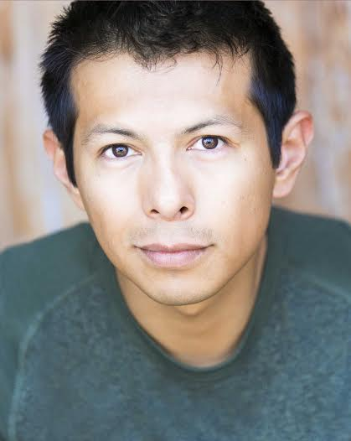
Hansel Ramirez
(213) 572-8371
Server, Caterer, Waiter

Experience
1994 - 1995 | Waiter, Mecano  - Waited on both high-end and casual customer types
1995 - 1996 | Waiter, Medusas  - Waited on both high-end and casual customer types
2010 - 2012 | Food Runner, Hotel Capella Pedregal, Cabo San Lucas  - Ran food for elite clientele  - Oswaldo: (624) 169-8770 MEX
2014 - Present | Server, Catering  - Wait on tables  - Run Food  - Bus tables  - Setup and brake down of tables, chairs, silverware, and glassware  - Brittani or Monisha: (310) 345-9482 US
Education
1995 - 1997 | Instituto Politecnico National

