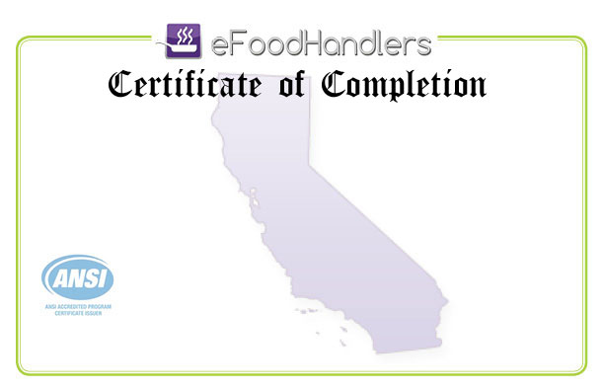

is Awarded to
JOVAN BAGNERISE
In recognition for completing
eFoodhandlers Basic Food Safety Course
CALIFORNIA Version
Certificate ID: 2018b2519635 Issued: 4/12/2018 Expires: 4/12/2021
Official Issuer:


