Chad Conley
San Francisco, California,
chadidconleyjr@gmail.com
Linkedin.com/in/chadid
Phone: +14153061773
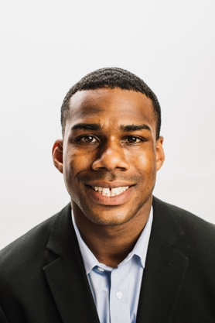

HIGHLIGHTS
• BA, Economics, San Francisco State University, May 2017
• TESOL/ TEFL Certificate, Asian College of Teachers, Bangkok, Thailand, April 2018
• Assistant Leadership San Francisco, San Francisco Chamber of Commerce
- Server, El Techo De Lolinda
- Food Runner, Waterbar
- Server, Fisherman’s Grotto #9
- ServSafe Food Handler card 2018

EDUCATION
- Bachelor of Arts in Economics San Francisco, California
- San Francisco State University 05/2017

EXPERIENCE
San Francisco Chamber of Commerce San Francisco, California
Administrative Assistant 11/2016-3/2018

- Communicate and collaborate with the CEO for proper execution of the ten sessions
- Create marketing material including brochures, event invitations and flyers on Adobe
- Operate the Leadership San Francisco website and LinkedIn group
- Provide assistance in the coordination of annual events

El Techo de Lolinda San Francisco, California
Server 1/2016-3/2018

- Quietly and efficiently serve pre-selected items at large events
- Deliver food and drink items, and answer special requests
- Remove each course from table and refill drinks
- Promptly respond to service issues and alert shift manager when needed

Fisherman’s Grotto #9 San Francisco, California
Server 05/2010-05/2014

- Explained food menu items to guests and made recommendations
- Prepared and delivered drinks to tables
- Served food and desserts to large groups
- Maintained dining room cleanliness

Waterbar San Francisco, California
Food Runner 05/2014-05/2016

- Assisted wait staff in running food, clearing tables and answering guest questions
- Ensured every dish was properly cooked, garnished, and platted correctly

Skills
- Information Technology
- Communication
- Customer Service
- Teamwork
- Mathematics

